Kingdom Emergence: It’s Time to Emerge
Isaiah 60:1-2, Psalm 102:13, 1 Peter 2:9


Greater New Bethel Sounds of Praise
351 Greyback Road
Summerville, SC 29483

Bishop Allen H. Simmons, Chief Apostle & Presiding Prelate
Elect Lady Janice Y. Simmons, Shepherd Mother
Bishop Designate Christian A. Simmons, Senior Pastor
Dr. Latitia Adams, Co-Pastor
Dr. Catherine H. Clark, Intercessor Pastor
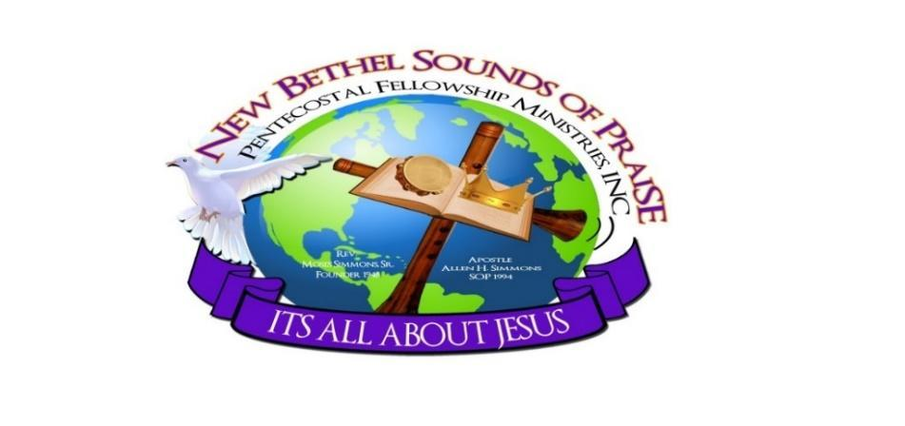

Living Intentionally in the Kingdom: Everywhere, All the Time, Every Part Focused, 24/7

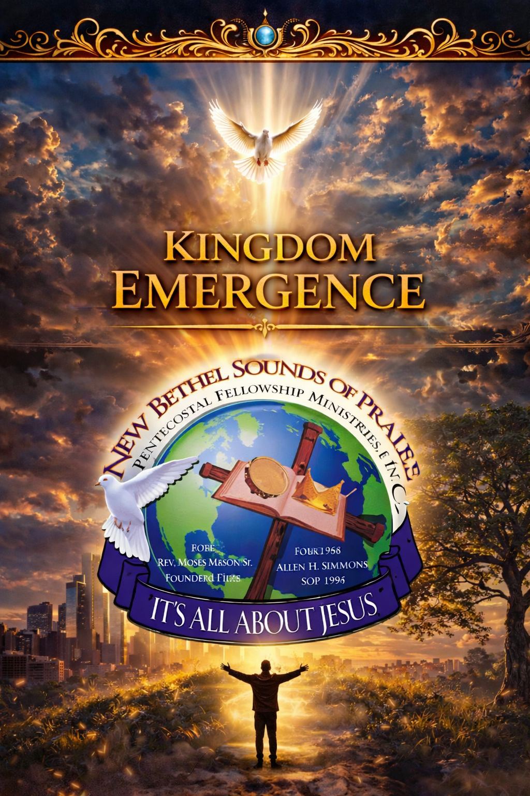

Editor in Chief – Sister Tiffany Newton
Contributing editors – Executive Pastor Kai David Hartwell, Associate Pastor Shirley Graves and Sis. Teryn Thomas

Emerge: Becoming Who Heaven Already Sees

A 50-Day Journey of Personal Consecration from Resurrection to Pentecost
Isaiah 60:1–2, Romans 8:19, Acts 2:2–4
Bishop Allen H. Simmons, Chief Apostle & Presiding Prelate

To the New Bethel Sounds of Praise family:
To every believer stepping into this sacred journey, grace, peace, and power be multiplied unto you. “It is of the Lord’s mercies that we are not consumed… they are new every morning: great is Thy faithfulness” (Lamentations 3:22–23). As you enter these 50 days from Resurrection to Pentecost, understand this is not routine devotion—it is divine alignment. The Spirit of the Lord is declaring, it’s time to emerge—not into something new God is creating, but into who Heaven has already seen you to be. Before your struggle, there was a declaration. Before your delay, there was a destiny. Before your current condition, there was a Kingdom position. Now is the time for your identity to align with God’s intention.
We have celebrated resurrection, but now we must walk in transformation. We have declared promises, but now we must become. For too long, many have been called but hidden, anointed but inactive, positioned but not yet manifested. Yet the Word declares, “the earnest expectation of the creation waits for the manifestation of the sons of God” (Romans 8:19). Creation is waiting on your emergence.
During these 50 days, we will walk the same spiritual pattern that the early church experienced: from Resurrection Awakening, to Identity Alignment, through Consecration & Refinement, into Kingdom Authority, and finally into Pentecostal Emergence. This is not accidental—it is divine order. Before the Spirit was poured out, there was preparation. Before the sound of heaven, there was surrender. Before the fire fell, there was consecration.
And just like the disciples in the Upper Room, this journey will require intentional prayer, spiritual discipline, honest reflection, and total surrender. This is not about perfection—it is about positioning. God is not looking for flawless vessels—He is looking for available ones. And as we consecrate ourselves, God will refine what needs to be purified, reveal what has been hidden, restore what has been broken, and release what has been waiting.
This journey will not leave you the same. It will produce clarity, strengthen your faith, awaken your spirit, and activate what God has already placed within you. Hear this clearly: you are not becoming someone new—you are becoming who Heaven already declared. So arise from complacency, break free from limitation, step out of hesitation, and align with your calling. “Arise, shine; for thy light is come, and the glory of the Lord is risen upon thee” (Isaiah 60:1–2).
The time for waiting is shifting into manifestation. Lean in, press in, and obey quickly, because what God is doing in you is about to be revealed through you. And when the appointed moment comes—suddenly—you will step into what Heaven has already prepared.
It’s Time to Emerge.

Emerging Through Consecration: Becoming Who Heaven Already Sees
Elect Lady Janice Y. Simmons, Shepherd Mother
To the New Bethel Sounds of Praise family:
Grace and peace to you as we enter this sacred 50-day journey of consecration from Resurrection to Pentecost. This is more than a spiritual exercise—it is a divine invitation to emerge into who God has already ordained you to be. “Before I formed you in the womb I knew you” (Jeremiah 1:5). This season calls us into deeper intimacy, intentional surrender, and full alignment with His will.
As we step into this journey, we do so with expectation, understanding that emergence is cultivated through consecration. “Sanctify yourselves: for tomorrow the Lord will do wonders among you” (Joshua 3:5). Over these 50 days, we are choosing to draw closer to God, quiet distractions, and allow Him to renew our minds and transform our lives (Romans 12:2). This is a shift from routine to relationship, from comfort to calling.
Emerging requires intentionality. It demands a consistent pursuit of God through daily surrender. Jesus reminds us, “Take up your cross daily and follow Me” (Luke 9:23). In consecration, we exchange our will for His, our weakness for His strength (2 Corinthians 12:9), and our uncertainty for divine clarity. It is here that God reveals our true identity in Him.
This journey follows divine order—awakening, alignment, refinement, authority, and emergence. Before Pentecost came power, there was preparation (Acts 1:4–5, 14). As we yield to God, He will refine us (Malachi 3:3), restore what has been lost (Joel 2:25), and reveal what has been hidden (Luke 8:17). What God is doing in this season is intentional and transformative.
Our commitment is to remain steadfast—to pray, reflect, listen, and obey. “Pray without ceasing” (1 Thessalonians 5:17) and “be doers of the word” (James 1:22). Together, we are emerging in unity, trusting that “where two or three are gathered… He is in the midst” (Matthew 18:20). This is a season where God strengthens us individually and corporately.
Be encouraged—“He who has begun a good work in you will complete it” (Philippians 1:6). You are not becoming someone new—you are emerging into who Heaven already sees. So draw near to God (James 4:8), remain faithful, and stay expectant. In this season, we choose to emerge—consecrated, aligned, and empowered by the Spirit of God.

Emerging Together: Becoming Who Heaven Already Sees
Bishop Designate Christian A. Simmons & Lady Melany Simmons
As we enter this sacred 50-day journey of consecration from Resurrection to Pentecost, we do so with purpose and expectation—not only for ourselves, but for our families, our church, our communities, and the advancement of God’s Kingdom. This is not an individual journey alone; it is a collective movement. What God is doing in us personally, He is also doing among us corporately. As Scripture reminds us, “You are a chosen generation, a royal priesthood… that you should show forth the praises of Him who has called you out of darkness into His marvelous light” (1 Peter 2:9). We are stepping into a season of emergence—becoming who Heaven already sees.
The Word of God declares, “For we are His workmanship, created in Christ Jesus for good works, which God prepared beforehand that we should walk in them” (Ephesians 2:10). This journey is about stepping into that divine design—new clarity, renewed strength, and intentional purpose. God is not calling us to remain where we were, but to move forward in alignment with His will. He is ordering our steps and establishing our path (Psalm 37:23), calling us to walk in what He has already prepared.
As the people of God, we have been called and commissioned—but before we fully step into that commission, we must be prepared. Consecration is that sacred preparation. It is the intentional pause where we quiet distractions, seek God through prayer, and allow Him to align our hearts. “Draw near to God and He will draw near to you” (James 4:8). In this place, we are strengthened inwardly (Ephesians 3:16) and positioned for what God desires to do through us.
During these 50 days, we are following a divine pattern—awakening, alignment, refinement, authority, and emergence. This is not accidental; it is God’s order. Before increase, there is preparation; before elevation, there is process. As Scripture reminds us, “Every branch that bears fruit He prunes, that it may bear more fruit” (John 15:2). In this season, God is shaping us, maturing us, and preparing us for greater impact.
God is calling us higher—into a deeper walk of faith, obedience, and sensitivity to His Spirit. As we yield ourselves, He leads us step by step, guiding us into truth and purpose (Psalm 32:8). This is a season of renewal, where strength is restored and vision is clarified. “They that wait upon the Lord shall renew their strength” (Isaiah 40:31). We believe God is positioning us to walk fully in what He has prepared.
As you engage in this journey, take time to reflect, repent, and realign. Stay anchored in prayer (Colossians 4:2) and committed to faithful obedience. Be encouraged, knowing that “Faithful is He who calls you, who also will do it” (1 Thessalonians 5:24). We are not striving to become something new—we are emerging into who Heaven already sees. Together, we move forward—consecrated, united, and empowered by the Spirit of God.

Kingdom Emergence: Becoming Who Heaven Already Sees
Dr. Latitia R. Adams, Co-Pastor
As we enter this consecrated 50-day journey from Resurrection to Pentecost, the voice of the Spirit is both clear and compelling—this is a season of emergence. God is not calling us into passive reflection, but into purposeful alignment. This is a defining moment where we are invited to step beyond where we have been and fully embrace who God has already declared us to be. What Heaven has established, earth must now reveal. This is a season that requires focus, faith, and forward movement.
Emergence begins in the unseen before it is revealed in the natural. Scripture teaches us in Hebrews 11:1 that “faith is the substance of things hoped for, the evidence of things not seen.” What God is bringing forth in this season will not always be immediately visible, but it is already in motion. Our responsibility is to remain grounded in faith, consistent in prayer, and confident in His promises. Just as the disciples waited in expectation for the outpouring of the Spirit, we are positioning ourselves for divine fulfillment.
This journey is not random—it follows divine order. From awakening to alignment, from refinement to authority, and ultimately into emergence, God is leading us step by step. Psalm 37:23 reminds us that “the steps of a good man are ordered by the Lord.” As we consecrate ourselves, we allow God to align our hearts, sharpen our focus, and prepare us for what lies ahead. Every moment of surrender increases our capacity to receive what He is releasing.
Growth in this season will require both discipline and devotion. God is not only advancing us—He is developing us. According to Colossians 2:6–7, we are called to be rooted and built up in Him. This means our foundation must be strengthened as we rise. True emergence is not rushed—it is established. When we allow God to do a complete work within us, we become stable, grounded, and prepared for sustained impact.
As we move forward, we must be willing to release anything that no longer aligns with God’s direction. Philippians 3:13 reminds us to “forget those things which are behind and reach forward to those things which are ahead.” Emergence requires courage—the courage to let go, to trust God’s process, and to step forward even when clarity is still unfolding. What God is doing now is not confined to our past—it is leading us into greater purpose.
Let this season be marked by intentional pursuit, unwavering faith, and active obedience. This is not a time to remain still—it is a time to move with God. As we commit ourselves to this journey, we do so knowing that “it is God who works in you both to will and to do for His good pleasure” (Philippians 2:13).
I am emerging—intentional, aligned, and fully committed to becoming who Heaven already sees.
The Kingdom is advancing. The process is active. Now is the time to emerge.

Kingdom Emergence: Becoming Who Heaven Already Sees
Elder Stanley Shephard, Lead Associate Pastor
God bless the NBSOP Saints,
We are entering a significant season—one that calls for awareness, intentionality, and spiritual readiness. This is a moment where God is drawing His people forward, not by pressure, but by purpose. Kingdom emergence is not about striving for something new, but stepping into what God has already established. As Isaiah 55:8–9 reminds us, God’s ways and thoughts are higher than ours, and this season invites us to align with His perspective rather than our own.
Emergence is a process that begins internally before it is expressed outwardly. What God develops in us during times of preparation is meant to be revealed in times of movement. Scripture tells us in Proverbs 16:9 that “a man’s heart plans his way, but the Lord directs his steps.” This reminds us that while we may not see every detail ahead, we can trust that God is ordering our path with precision and purpose.
This season requires a deeper level of spiritual awareness. It is not enough to simply recognize that change is happening—we must be responsive to what God is doing. Hebrews 12:11 reminds us that growth and discipline, though sometimes uncomfortable, produce lasting fruit. God uses these moments to strengthen our character, refine our thinking, and prepare us for what lies ahead.
As we walk through this time of consecration, we are positioning ourselves to hear clearly, respond faithfully, and move confidently. Psalm 25:4–5 encourages us to seek God’s direction: “Show me Your ways, O Lord; teach me Your paths.” When we remain open to His guidance, He leads us step by step into alignment with His will.
We can move forward with confidence, knowing that God is intentional in all that He does. Lamentations 3:25 reminds us that “the Lord is good to those who wait for Him, to the soul who seeks Him.” This is a season where patience, trust, and obedience work together to produce growth that is both steady and lasting.
As we continue in this journey, let us remain focused, grounded, and committed. This is not a moment to hesitate, but to respond with faith and clarity. God is leading us forward, and as we follow Him, we will find ourselves walking in what He has already prepared.
Let us move forward—aligned, prepared, and ready to emerge.

Emergence: Spiritual Renewal & Hospitality in Action
Associate Pastor Elder Thomasena Malloy
As we enter this sacred season of consecration, it is an opportunity for each of us to pause, reflect, and allow God to renew every area of our lives. Emergence calls us to move forward with intention—releasing what no longer aligns with God and embracing the life He is calling us to live. This is not only a season of personal renewal, but also a time to grow in how we care for and serve one another within the body of Christ.
Spiritual growth requires continual examination and surrender. Scripture reminds us that we all fall short (Romans 3:23), but through repentance, we are restored and realigned with God’s will. Renewal begins with honesty before God and a willingness to turn away from anything that disrupts our fellowship with Him. As Psalm 34:18 reminds us, “The Lord is near to those who have a broken heart,” and it is in that place of humility that transformation begins.
As we draw closer to God, we are also called to reflect His nature in how we treat others. Hospitality is an expression of spiritual maturity. Romans 12:13 instructs us to be “given to hospitality,” and Hebrews 13:2 reminds us not to neglect showing kindness to others. Emerging in this season means opening our hearts, extending grace, and creating space for others to feel seen, valued, and supported within the household of faith.
The Word of God remains central to our renewal. 2 Timothy 3:16–17 reminds us that Scripture equips us for every good work, while Psalm 119:105 teaches that God’s Word provides direction for our daily walk. As we immerse ourselves in the Word, our thinking is transformed, and we become more aligned with God’s character—allowing His love to flow through us in both word and action.
Renewal is not only inward—it produces outward evidence. God transforms our hearts so that our lives reflect His goodness. As Colossians 3:12–14 instructs us, we are to put on compassion, kindness, humility, and patience—qualities that strengthen our relationships and build unity among believers. Hospitality becomes a natural extension of a renewed heart, as we serve one another with love and sincerity.
As we continue in this season of emergence, let us remain committed to growth, both spiritually and relationally. Let us seek God daily, walk in obedience, and extend His love to others through acts of kindness and service. “Be transformed by the renewing of your mind” (Romans 12:2), and allow that transformation to shape how you live and how you serve.
May this season of Emergence be marked by spiritual renewal, a deeper commitment to God’s Word, and a genuine expression of hospitality toward one another. As we are renewed within, let that renewal be seen in how we love, welcome, and care for the saints.

Kingdom Emergence — It’s Time to Emerge
Elder Bernie Snider, Associate Pastor
A Message of Encouragement to the Greater New Bethel Church Family
Greetings in the precious name of our Lord and Savior, Jesus Christ!
As we enter this sacred season of consecration, we do so with a clear understanding that this is not an ordinary moment—it is a divine invitation to move forward with intention. God is calling His people to arise and step into who He has already purposed them to be. This is not a season for passive faith, but for deliberate pursuit. As the Word declares, “Seek the Lord while He may be found, call upon Him while He is near” (Isaiah 55:6). Kingdom emergence requires that we pursue God with focus, urgency, and a heart fully committed to Him.
Emergence is not accidental—it is the result of intentional alignment with God’s will. Scripture reminds us, “Draw near to God, and He will draw near to you” (James 4:8). As we move closer to Him, He begins to shape our perspective, refine our character, and position us for what He has already prepared. This is the season where we move from knowing about God to walking closely with Him—where our pursuit becomes personal, consistent, and unwavering.
As we move forward, we must understand that focus is pivotal in this season. We cannot afford to be distracted by the ways of the world or pulled away by competing priorities. Hebrews 12:2 instructs us to keep our eyes fixed on Jesus, the Author and Finisher of our faith. When our focus remains on Him, we are strengthened, directed, and sustained. Distractions will come, but discipline and devotion will keep us anchored. What God is unfolding requires our full attention and unwavering commitment.
God is not calling us to become something new—He is calling us to emerge into who He already sees. “For we walk by faith, not by sight” (2 Corinthians 5:7). This means we must trust what God has spoken, even when we do not yet see it fully manifested. Emergence requires faith to move forward, discipline to remain consistent, and obedience to act when God speaks.
Church family, this is a season that calls for intentionality in every area of our lives. Our pursuit of God must be deliberate, our prayer life consistent, and our commitment unwavering. “Those who seek Me diligently will find Me” (Proverbs 8:17). When we seek Him with our whole heart, He reveals direction, provides clarity, and strengthens us for the journey ahead.
Let us move forward with focus, faith, and determination. This is not the time to be distracted, delayed, or discouraged. God is leading us into alignment with His will, and as we follow Him, we will walk fully into what He has already prepared.
Be encouraged, Greater New Bethel family. Stay intentional. Stay focused. Stay committed.
It’s time to emerge—into who Heaven already sees.

Emerge—Becoming Who Heaven Already Sees
Encouragement from Associate Pastor Dr. Dolores W. Simpson
In ministries centered on education, scholarship, tutoring, and Sunday School, emerging means embracing one’s authentic identity as recognized by God. This theme emphasizes that God views individuals through the lens of their future, perfected selves. Several scriptural references support this perspective: Genesis 1:27 highlights creation in God's image, 1 Peter 2:9 affirms that believers are chosen, Romans 6:6 focuses on forgiveness, and Psalm 111:9 addresses redemption.
In the context of overseeing multiple ministries focused on education, my objective is to facilitate growth toward the identity envisioned by God.
Building on these scriptural foundations, several strategic areas have been identified to support growth and transformation within our educational ministries. Pairing each ministry area with relevant scriptural references will further strengthen the spiritual basis for these initiatives and inspire deeper reflection among all involved.
Key areas of ministry development include:
Generational Ministry: Addressing challenges faced by Baby Boomers (1946–1964), Generation X (1965–1980), Millennials (1981–1996), Generation Z (1997–2012), and Generation Alpha (2010–2024), particularly anxiety, through relational and mentoring-based discipleship.
Technological Integration: Leveraging artificial intelligence, social media, and digital tools to enhance outreach and instruction, while navigating ethical, theological, and practical considerations.
Partnership with Parents: Transitioning from traditional teaching models to collaborative efforts with families, transforming education into a shared ministry.
Academic Gospel Integration: Encouraging students to view all academic disciplines as opportunities to witness God's glory and understand their roles as bearers of God’s image. As we continue to emerge academically, we are offering continuing educational biblical training for anyone who wants to emerge along with us in our educational efforts.
Field-Based Training: Prioritizing practical, supervised, and contextual ministry preparation over purely academic or theoretical approaches.
As the Associate Pastor of Education, I aim to bring these ministries together so that we can “Become Who Heaven Already Sees”.

Emerge - Becoming Who Heaven Already Sees
By: Pastor Yvonne H. Wigfall
A Pastor or Leader's job is seldom easy. Whatever context he or she ministers in, he or she is likely to face Holiness countless pressures from the surrounding culture, from within his congregation, and even from within his own heart, mind, and spirit. In the face of such challenges, the surest place to turn is God's Word itself, which offers both a heartening vision of the pastor's role and wisdom for navigating its fulfillment.
Pastors can emerge in the ministry by embracing a mindset of continuous learning and self-improvement. Here are some ways a Pastor can accomplish this:
Strive to emerge in Holiness - Personal holiness is indispensable because you serve a holy God (1 Peter 4:14-16). But your growth in godliness must be rooted in faithfulness to Christ, not the pursuit of fruitful ministry. Your motivation must rest on the character of God because no other incentive will be constant.
Strive to emerge in obedience and discipline - People learn discipline from the Leader as well as doctrine. Paul's example with Timothy reminds us that the people we lead and serve will inherit more from us than simply our sermons (2 Timothy 3:10). In fact, God commands them to do so (Hebrews 13:7).
Your conduct impacts the effectiveness of your communication. A brilliant sermon can be silenced by a lifestyle that contradicts it. As leaders, we must strive "to keep the commandment unstained" (1 Timothy 6:14), so that "the word of God may not be reviled" (Titus 2:5). Leaders put hours into studying the text so that they can faithfully expound upon its meaning. Do not short-circuit your efforts by forsaking your own spirituality.
Strive to emerge spiritually - The Pastor's, spiritual health matters to the church. Their pursuit of Christ impacts the people. The Pastor's daily schedule should reflect this. The Pastor's spirituality can inspire or impede the salvation of others.
A Pastor should take time to Invest in his spiritual life by making time for Prayer, Bible Study, and Worship. Attend retreats, conferences, and other spiritual events that can help him to deepen his relationship with God. Seek out spiritual mentors or accountability partners who can provide support and guidance as you grow in your faith.
Attending ministry training programs is another effective way to develop your ministry skills. Many churches and organizations offer training programs, workshops, and conferences that focus on specific ministry skills such as preaching, leadership, or counseling.
Collaborating with others is another effective way to develop your ministry skills and grow spiritually. Work with other ministers or leaders in your church or community to plan events, coordinate ministries, or share resources.
By focusing on these areas, Pastors can emerge as more effective leaders and become who heaven has already seen.

Emerge—Becoming Who Heaven Already Sees
Encouragement from Pastor Jonathan Simmons
Pastor of Music & Worship Arts
As we embrace the call to “Emerge—Becoming Who Heaven Already Sees,” I want to encourage every believer to recognize that this emergence must also take place in our worship and praise. Worship is not simply an expression—it is a posture. It is the place where identity is revealed, alignment is established, and transformation begins. Scripture declares, “God is Spirit, and those who worship Him must worship in spirit and in truth” (John 4:24). In this season, God is calling us to emerge as true worshipers—those whose lives reflect not only moments of praise, but a continual lifestyle of worship.
Emerging in worship requires intentionality. It is not confined to a song or a service—it is cultivated through daily surrender and awareness of God’s presence. Psalm 34:1 reminds us, “I will bless the Lord at all times: His praise shall continually be in my mouth.” This is a call to consistency. Worship is not seasonal—it is continual. As we grow in our understanding of who God is, our response becomes deeper, more authentic, and more aligned with His nature.
As we emerge, our worship must also become expressive and unrestrained. The Word declares, “Make a joyful noise unto the Lord, all ye lands” (Psalm 100:1), and “Shout unto God with the voice of triumph” (Psalm 47:1). Worship is not silent—it is alive. It is found in singing, in lifting our voices, in clapping our hands, and in declaring the goodness of God. The psalmist reminds us to praise Him with instruments—“Praise Him with the psaltery and harp” (Psalm 150:3)—and ultimately, “Let everything that hath breath praise the Lord” (Psalm 150:6). As we walk in emergence, our praise should reflect the victory, the freedom, and the identity God has already given us.
Praise and worship also serve as spiritual catalysts for breakthrough and transformation. Throughout Scripture, we see that when God’s people lifted their voices in praise, atmospheres shifted. In 2 Chronicles 20:22, as they began to sing and praise, God moved on their behalf. This reminds us that worship is not passive—it is powerful. It releases faith, strengthens our spirit, and invites the presence of God into every situation we face.
As we emerge in worship, we must also grow in excellence and discipline. Colossians 3:23 instructs us, “Whatever you do, do it heartily, as to the Lord and not to men.” Whether you are leading, singing, playing, or simply lifting your voice, your worship matters. God is calling us to bring our best—not for performance, but as an offering of honor and reverence unto Him.
This season also calls us to worship beyond the walls of the church. Romans 12:1 reminds us to present our lives as a living sacrifice, holy and acceptable unto God. True worship extends into how we live, how we serve, and how we represent God daily. Our lives become the expression of the worship we offer.
Be encouraged to pursue God more deeply in your worship. Let your praise be intentional, your worship be expressive, and your heart remain open to His presence. As you draw near to Him, He will draw near to you (James 4:8), revealing more of Himself and shaping you into who He has already called you to be.
You are not striving to become a worshiper—you are emerging as one. God has already declared it. Now is the time to walk in it.
Emerge—in worship, in praise, and in His presence.

Be Encouraged, Stay Committed, and Emerge in This Season
Dr. Catherine H. Clark, Associate & Intercessor Pastor
This act of emerging in intercession to God refers to praying or meditating on behalf of others before God. It is the selfless expression of love and concern, rooted in the belief that God sees, listens to, and acts upon the prayers of His people.
As intercessors, we have been summoned by God—anointed, appointed, and set apart—to bombard Heaven, standing in the gap and on the wall in prayer and fasting for our leaders and the body of Christ, advocating for all those who are in need of prayer. There is power in intercession in the lives of God’s people, because prayer changes things, and there is healing in prayer. Intercession is not just a ritual, but a heartfelt act of faith that engages the power of God to bring about change in people’s lives.
Intercession is a vital aspect of Christian prayer, reflecting God’s heart for humanity and the importance of standing in the gap for others. We will stand in the gap and intercede for others, for God still looks for a people who will stand in the gap for the land—we will be that people. We believe prayer is not polite background music; it is the trumpet, it is the wall, it is the rescue line.
We will pray for all people and for those in authority, as Scripture commands. We will come boldly to the throne of grace through Jesus Christ, our one mediator (Hebrews 4:16). We will yield to the Holy Spirit, who helps our weakness and prays within us according to the will of God. We will labor in love, bearing one another’s burdens, lifting holy hands without wrath or doubting. Praise be to God—prayer still turns the tide, and mercy still triumphs.
Intercession is stepping between a need and a holy God with a plea for mercy. We will emerge in intercession to God, becoming who Heaven sees us to be—standing between a need and a holy God with a plea for mercy. The old definition says it well: mediation, a solicitation in favor of another. Scripture brings it into our daily prayer life—supplication, prayers, intercession, and giving of thanks for all people.
Thanks be unto God, we are a part of a royal priesthood. We do not stand outside of the veil; by His blood, we enter boldly to find grace to help in time of need. So we ask, seek, and knock. Our Father gives good gifts, even the Holy Spirit, to those who ask Him.
Through intercession, we know prayer changes outcomes—not because God is fickle, but because He ordained prayer as a means. He sought a man to stand in the gap—sometimes He found one and mercy came; sometimes He found none, and judgment fell (Ezekiel 22:30).
Intercession is a powerful tool for spiritual warfare, for prayer is the battleground of victory. God is not deaf to the cries of His people—He is waiting for one: one who will pray, one who will believe, one who will care enough to intercede.
As intercessors, we are summoned by God. We have been called out, set apart, anointed, and appointed for such a time as this, where prayer is needed for the healing of the nation. Prayer is the battleground of victory.
God is not deaf to the cries of His people—He is waiting for one: one who will pray, one who will believe, one who will care enough to intercede. When Abraham spoke, God listened. When Daniel prayed, kingdoms shifted. When Jesus knelt, salvation came. Intercession bridges eternity and time. Heaven’s answers are waiting for an earthly voice—will it be yours?
We will, as intercessors, stand in the gap!
Intercession is standing in the breaches through Jesus Christ, our great intercessor and only mediator. The Holy Spirit is our divine prayer partner, helping us stand in the gap and on the wall, carrying burdens and making intercession.
Oh, what blessings flow when we pray for others—one story, one Savior, one people of prayer. This is a practical call to step into the breaches. As intercessors, we will continue to emerge and become who Heaven already sees us to be.
We will continue emerging and interceding in prayer, for this is a season to listen to God in a way that produces obedience and wise choices. As a result of intercessory prayer, hearts are being changed, healing is taking place, minds are being renewed, and salvation and deliverance are available to all.
It is the will of God that we pray.
Prayer is the key, and faith unlocks the door.
It’s time to emerge—through prayer, through service, and through obedience to God’s will.

Emergence – Love and Serving Others
Encouragement from Associate Pastor Shirley Graves
God has given me a task to bring people together, and through this, He is showing how a ministry can be cultivated in a spiritual way.
As a leader and a team player, I strive to help others emerge together, share new ideas, and motivate one another. God has blessed me with a great team of people to assist in this ministry, and we do it all in the love of Christ. As it says in Matthew 5:16, “Let your light so shine before men, that they may see your good works, and glorify your Father which is in heaven.”
Mothers Circle of Love was given by God because He knew I have always had a heart for caring for seniors and the elderly. This reflects true love, especially as many of them have special needs and require compassionate care. The roles have now been reversed—those who once cared for others are now in need of someone to care for them. This ministry allows us to give back to them with love and dignity.
Summer Camp is a ministry designed to assist parents by providing affordable, Christ-centered childcare during the summer months. It gives children the opportunity to continue their academic growth while also learning Christian principles that help develop them in the Word of God, all within a safe and nurturing environment. We provide structured, cost-efficient supervision, especially during challenging financial times.
By working within the community, we are able to come together, thrive, and emerge as one.
In conclusion, our ministry strives to serve both within the walls of the church and out in the community. I want to thank my leaders for allowing me to emerge in love and service in the way that God has given it to me.

Emerging to Move Forward
Encouragement from Pastor Mother Annabelle Wright

I have been working in ministry from the old church to the new church. Throughout the years, God has blessed me to oversee the Program Committee, We Care, Shepherd’s Care, and the Food Pantry ministries. Through each of these ministries, God has graced me to build a sincere love for helping people, taught me how to adapt to change, and allowed us to help the ministry financially sustain and grow through acts of service and kindness.
We Care allows us to support individuals with medical needs, hospital stays, and to offer comfort during times of bereavement.
I have served in many ministries and in many different capacities throughout the years. Wherever I was planted, I blossomed. It is my humble prayer that God nurtures the seeds that I have planted in others along this journey.
Even now, as I have experienced a few medical conditions, I stand as a witness that what the enemy meant for evil, God has turned around for my good.
As I continue emerging in Christ, I am reminded that growth is a continual process. God is calling us higher—to move forward in faith, to trust Him in every season, and to walk boldly into what He has prepared for us. Emerging in Christ means not remaining where we were, but pressing forward into purpose, strengthened, renewed, and anchored in His Word.
In conclusion, of all the assignments God has given me, I am grateful to pass the baton, knowing that the work of the Lord will continue to move forward. As it is written in 1 Corinthians 3:8, “Now he that planteth and he that watereth are one: and every man shall receive his own reward according to his own labour.”

Emerging with God’s People
Encouragement from Associate Pastor Charles Graves

It is truly an honor to work with God’s people. With His guidance and assistance, all things are accomplished in an excellent and meaningful way. When we keep God on our minds and in our hearts, He equips us to do whatever is needed as faithful team players, serving with unity and purpose.
Emerging in service means being willing and available to do what is needed for the Kingdom. It means stepping forward with a ready heart, knowing that God will give us the strength and wisdom to carry out every assignment.

Working alongside the deacons keeps us active and engaged, ensuring that the work of the ministry is completed with excellence and care. Together, we labor to make sure that every need is met through God’s help, and that all things are done in a spirit of love and order.

As we continue emerging and working together, we are reminded that our service is not in vain. God uses each of us in unique ways, and when we come together, the work is accomplished greatly. There is strength in unity, and there is power in serving one another with a willing heart.

We also remain committed to prayer and to preparing for worship, coming together for Sunday service to uplift God’s people. Through the reading of God’s Word, we bring comfort, encouragement, and guidance to those in need, reminding them that His Word is a source of peace and strength in every season.

As we move forward, let us continue emerging in our service—growing, working, and walking together in love. When we serve God’s people with humility and faith, we reflect His heart, and our work becomes a blessing not only to others, but to ourselves as well.



Daily Consecration Prayer Guide
Introduction:
Setting aside daily time for prayer is a powerful spiritual discipline that allows believers to connect with God, seek His guidance, and grow in their faith. This guide is designed to help you establish a consecrated daily prayer routine, offering flexibility in duration to accommodate different schedules and commitments. Whether you have just a few minutes or an hour, each moment spent in prayer is valuable. Please pre-plan a set time frame that best fits your schedule and spiritual needs. The key is consistency and intentionality in seeking God’s presence every day.
Scripture for Meditation:
As you begin each prayer session, start by meditating on a scripture to focus your heart and mind on God. Here are suggestions that align with the essence of daily consecration and communion with the Lord:
- Psalm 46:10 - “Be still, and know that I am God; I will be exalted among the nations, I will be exalted in the earth.”
- Philippians 4:6-7 - “Do not be anxious about anything, but in every situation, by prayer and petition, with thanksgiving, present your requests to God. And the peace of God, which transcends all understanding, will guard your hearts and your minds in Christ Jesus.”
- Matthew 6:6 - “But when you pray, go into your room, close the door and pray to your Father, who is unseen. Then your Father, who sees what is done in secret, will reward you.”
- Jeremiah 29:12 - “Then you will call on me and come and pray to me, and I will listen to you.”
- 1 Thessalonians 5:16-18 - “Rejoice always, pray continually, give thanks in all circumstances; for this is God’s will for you in Christ Jesus.”
- Psalm 145:18 - “The Lord is near to all who call on him, to all who call on him in truth.”
- James 5:16 - “Therefore confess your sins to each other and pray for each other so that you may be healed. The prayer of a righteous person is powerful and effective.”
How to Structure Your Prayer Time:
- Praise and Worship (2 minutes for shorter sessions, 5 minutes for longer): Begin with acknowledging God’s nature, greatness, and love.
- Confession and Repentance (1-5 minutes): Confess your sins and seek God’s forgiveness, aiming for a pure heart.
- Thanksgiving (1-5 minutes): Express gratitude for God’s blessings, provision, and grace in your life.
- Supplication and Intercession (3-45 minutes depending on your chosen duration): Present your needs and the needs of others before God, praying for guidance, healing, provision, and for God’s will to be done.
- Listening and Reflection (1-5 minutes): Spend the final minutes of your prayer time in silence, listening for God’s voice, and reflecting on the scripture you meditated on at the beginning.
Conclusion:
Prayer is a dynamic and intimate way to deepen your relationship with God. By consecrating time daily for prayer, you are opening your heart to receive God’s love, wisdom, and direction. Remember, the length of time is not as crucial as the sincerity and dedication of your heart.

Praying Scripture Guide: Finding Words When You Are at a Loss
Introduction:
There are moments in our spiritual journey when words fail us in prayer—times of deep anguish, confusion, joy, or even in the silence of awe. In these times, the Psalms and other scriptures serve as a profound resource, giving voice to our hearts’ cries and praises. This guide aims to help you navigate through various emotional and spiritual landscapes by praying the scriptures. Below, find themes and corresponding Psalms to guide you in praying scripture when you're at a loss for words.
Praying Scripture Resource:
When words are hard to find, let these Psalms speak on your behalf, guiding your heart back to God’s presence and His truths.
- When we have messed up: Psalm 32 - Find forgiveness and the joy of being cleansed from sin.
- When we are in trouble: Psalm 27 - Seek courage, strength, and the assurance of God’s protection.
- When we are broken: Psalm 42 - Express your deep longing for God in times of despair.
- When we are oppressed and need justice: Psalm 9 - Affirm God’s sovereignty and His justice for the oppressed.
- When we are in the middle of a trial: Psalm 28 - Cry out for deliverance and receive God’s strength.
- When experiencing relational conflict: Psalm 133 - Pray for unity and the blessing that comes with harmony.
- When you want God’s blessing: Psalm 1 - Meditate on the path to true prosperity and blessing through obedience to God.
- When you want to praise God: Psalm 145 - Join in the chorus of creation, praising God for His mighty acts and loving character.
- When you don’t want to praise God: Psalm 104 - Remind your heart of the reasons to praise God by reflecting on His creation and provision.
- When you want to live for God: Psalm 15 - Contemplate the characteristics of those who dwell with God.
- When you need comfort: Psalm 23 - Rest in the presence of the Good Shepherd who provides and protects.
- When you need to be reminded of what Jesus did for us: Psalm 22 - See the prophetic depiction of Christ’s suffering and the victory that followed.
- When you need forgiveness: Psalm 51 - Confess and return to God with a contrite heart, seeking His mercy.
- When you need to cry out in desperation: Psalm 88 - Bring your deepest despair before God, knowing He hears every cry.
- When you need to refocus: Psalm 37 - Trust in the Lord instead of fretting over evildoers.
- When you need God’s help: Psalm 57 - Take refuge in God’s unfailing love and faithfulness amid storms.
- When you feel God is distant or indifferent: Psalm 139 - Remember that God is intimately acquainted with all your ways.
- When you feel God has forgotten you: Psalm 13 - Share your feelings of abandonment and trust in God’s steadfast love.
- When you doubt your worth: Psalm 8 - Marvel at the honor and care God gives to humanity, including you.
- When you doubt God’s goodness: Psalm 19 - Witness the perfection of God’s laws and the sweetness of His statutes.
- When you doubt God’s love: Psalm 103 - Recall the benefits and mercies of God, which are new every morning.
- When you doubt God’s forgiveness: Psalm 130 - Wait for the Lord with hope, knowing He offers full redemption.
- When you doubt God’s ability to help: Psalm 146 - Praise God for His help and hope, remembering His faithfulness through all generations.
- When you doubt God’s faithfulness: Psalm 136 - Rehearse the steadfast love of the Lord that endures forever.
Conclusion:
Praying scripture is a powerful way to align our hearts with God’s heart, especially when our own words fall short. These Psalms serve as a reminder that no matter what we face, we can find solace, guidance, and communion with God through His Word. Let the timeless prayers of the Psalms lead you into deeper intimacy with God, transforming your heart and mind in every season of life.

Emerge: Becoming Who Heaven Already Sees

A 50-Day Journey of Consecration from Resurrection to Pentecost

Introduction
Every resurrection creates the possibility for emergence.
When Jesus rose from the grave, it was not only a victory over death—it was the beginning of a divine unveiling. The resurrection was not the final chapter of redemption; it was the opening of a new era. For forty days after rising, Jesus appeared to His disciples, teaching them about the Kingdom of God (Acts 1:3). Then He instructed them to wait. Not because their assignment was uncertain, but because their empowerment was coming.
Between resurrection and Pentecost, something sacred happened. The disciples were being prepared to emerge.
They had walked with Jesus. They had witnessed miracles. They had heard His teaching. Yet there was still another dimension of transformation required before they could step fully into their assignment. Jesus told them plainly, “Tarry in the city of Jerusalem until you are endued with power from on high” (Luke 24:49). Their waiting was not passive; it was consecration. It was alignment. It was preparation for manifestation.
This 50-day journey is built upon that same divine pattern.
Many believers celebrate the resurrection but never fully step into the life it makes possible. They acknowledge the victory of Christ but remain hidden behind fear, doubt, insecurity, past failures, or spiritual stagnation. Yet Scripture declares that creation itself is waiting for something more—the revealing of the sons and daughters of God (Romans 8:19).
In other words, heaven has already declared who you are. The question is whether you will emerge into it.
Emergence is not about becoming someone new; it is about revealing who God has already called you to be. It is the process of shedding spiritual limitations, renewing the mind, aligning with divine purpose, and allowing the Holy Spirit to activate the life that Christ secured through the cross and resurrection.
This manual is designed as a season of consecration, reflection, and spiritual activation during the fifty days between Easter and Pentecost. Each day invites you into deeper alignment with God through Scripture, reflection, prayer, and practical spiritual direction.
During these fifty days you will:
- Release the limitations of your past season
- Rediscover your identity in Christ
- Allow God to refine and consecrate your heart
- Step into spiritual authority and Kingdom purpose
- Prepare for a fresh infilling and empowerment of the Holy Spirit
Just as the early believers emerged from the Upper Room with boldness, clarity, and supernatural power, this journey is intended to position you for your own moment of spiritual emergence.
You are not reading this manual by accident. Heaven is calling you forward.
It is time to arise.
It is time to step out of what confined you.
It is time to walk in who God has declared you to be.
It is time to emerge.

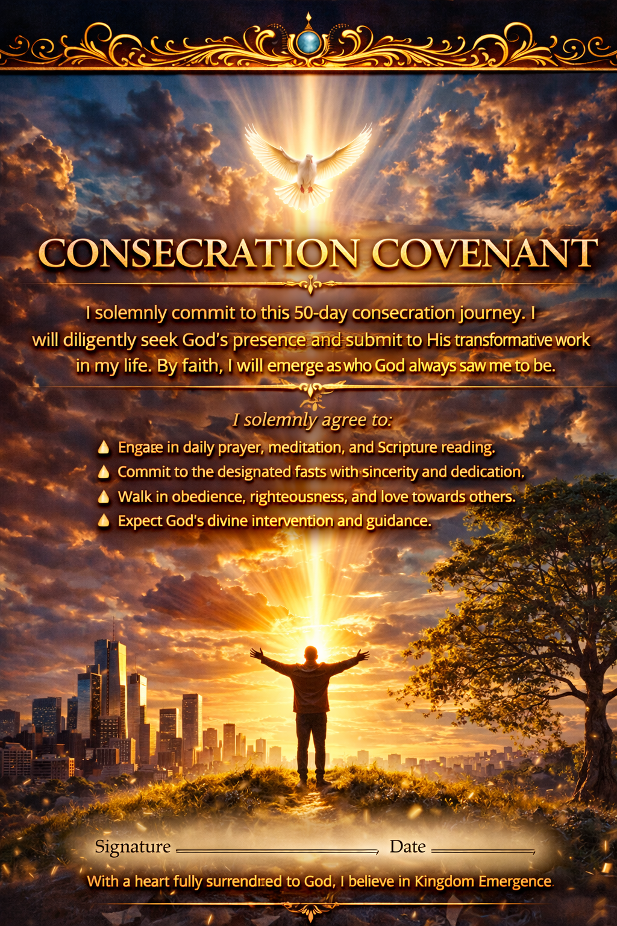

The Consecration Covenant(To be prayed on Day 1)
Heavenly Father,
Today I enter into this season of consecration with a willing heart and an open spirit.
I acknowledge that You are calling me into a deeper place of alignment, transformation, and spiritual awakening. I recognize that the journey ahead is not merely about reading words on a page, but about allowing Your Spirit to shape my life.
Over the next fifty days, I commit to seeking You with intentionality and sincerity.
I consecrate my mind to Your truth.
I consecrate my heart to Your will.
I consecrate my life to Your purpose.
I surrender every distraction, every limitation, and every mindset that has kept me from fully walking in the identity You have given me through Christ.
I declare that this season will be a time of renewal.
Where there has been confusion, You will bring clarity. Where there has been weariness, You will release strength. Where there has been delay, You will bring divine alignment.
Holy Spirit, I invite You to search my heart, refine my motives, renew my thinking, and empower my spirit.
Prepare me in the secret place so that I may emerge in the place of assignment.
Just as the disciples waited with expectation in the Upper Room, I position myself in faith, believing that You are preparing me for greater intimacy, greater authority, and greater effectiveness in Your Kingdom.
I commit these fifty days to You.
Transform me. Align me. Prepare me.
And when this season is complete, may my life reflect the power, purpose, and presence of Christ more clearly than ever before.
In Jesus’ name,
Amen.

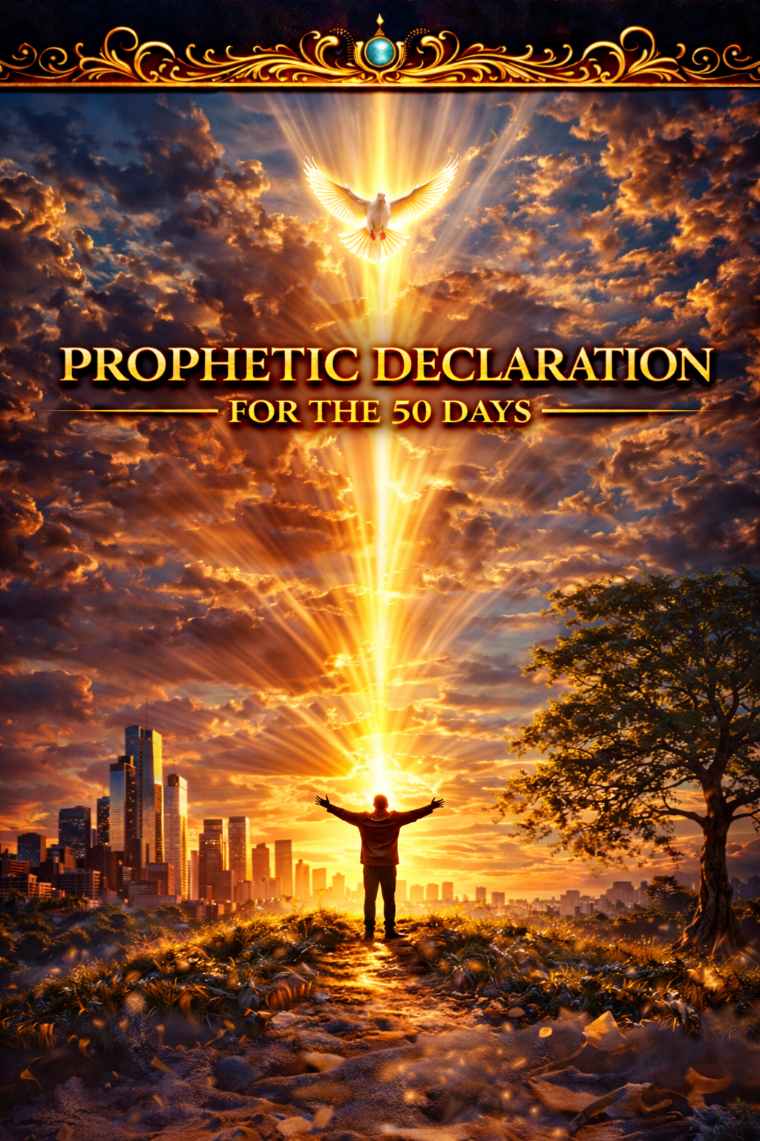

Prophetic Declaration for the 50 Days
Heavenly Father,
I enter this 50-day journey with expectation and surrender. I acknowledge that through the resurrection of Jesus Christ, a new life has been made available to me. I refuse to remain hidden in old mindsets, past disappointments, or spiritual complacency.
I declare that this is a season of emergence.
Over the next fifty days, I will align my heart, mind, and spirit with the purposes of God. Every weight, every fear, every limiting belief, and every spiritual hindrance that has attempted to hold me back is being removed by the power of the Holy Spirit.
I declare that I am rising into the identity Heaven already sees.
Where there was confusion, clarity will emerge.
Where there was weakness, strength will arise.
Where there was delay, divine acceleration will begin.
I open my life to the refining work of God. I welcome the discipline of consecration, the transformation of my mind, and the renewal of my spirit. I believe that God is preparing me not only for personal growth but for Kingdom assignment.
As the disciples waited in the Upper Room with expectation, I also position myself in faith, knowing that God is preparing me for greater effectiveness, deeper intimacy, and fresh empowerment.
I declare that by the end of this journey I will not be the same person who began it.
My faith will be stronger.
My vision will be clearer.
My authority will be greater.
My obedience will be deeper.
I will emerge with courage, purpose, and power.
I receive the promise of the Father.
I welcome the work of the Holy Spirit.
And I step forward into the life God has already ordained for me.
In Jesus’ name,
Amen.

The 5-Phase Journey Toward Pentecost

Phase 1 — Resurrection Awakening (Days 1–10)
Theme: Awaken to New Life
Focus: Breaking free from spiritual stagnation and embracing resurrection identity.
Key concepts:
- Leaving the grave clothes behind
- Renewing the mind
- Reawakening spiritual passion
- Recognizing the living Christ
Objective: Move from survival to spiritual awakening.

Phase 2 — Identity Alignment (Days 11–20)
Theme: Becoming Who God Says You Are
Focus: Understanding sonship, authority, and Kingdom identity.
Key concepts:
- Adoption into God’s family
- Breaking insecurity and comparison
- Embracing divine purpose
- Renewing self-concept through Scripture
Objective: Establish a Kingdom identity.

Phase 3 — Consecration and Refinement (Days 21–30)
Theme: Prepared in the Secret Place
Focus: Spiritual purification and deeper intimacy with God.
Key concepts:
- Surrender and obedience
- The discipline of prayer and fasting
- Letting go of distractions
- Cultivating spiritual sensitivity
Objective: Increase spiritual capacity for God’s presence.

Phase 4 — Kingdom Authority (Days 31–40)
Theme: Walking in Spiritual Authority
Focus: Learning to live and operate with Kingdom authority.
Key concepts:
- The authority of the believer
- Spiritual warfare
- The power of agreement and declaration
- Operating in faith and boldness
Objective: Activate Kingdom authority in daily life.

Phase 5 — Pentecostal Emergence (Days 41–50)
Theme: Clothed With Power
Focus: Empowerment, boldness, and public manifestation of faith.
Key concepts:
- The promise of the Holy Spirit
- Expectation and unity
- Spiritual empowerment
- Living as a witness to the Kingdom
Objective: Emerge into Spirit-empowered living.

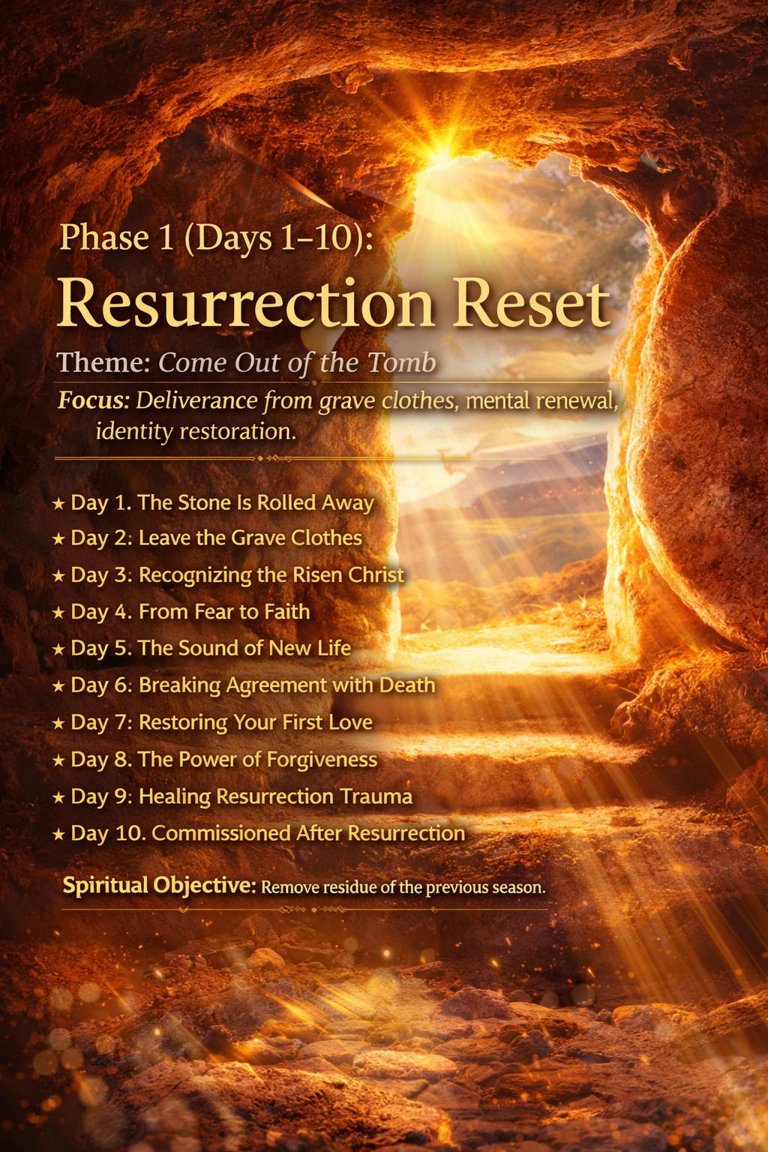

Day 1 — The Stone Has Been Rolled Away

Theme Scripture
Matthew 28:6
"He is not here; for He is risen, as He said. Come, see the place where the Lord lay."

Reflection
The resurrection of Jesus Christ stands as the greatest turning point in human history. What appeared to be the final defeat at the cross became the foundation of eternal victory. When the women arrived at the tomb expecting to find Jesus’ body, they instead encountered an empty grave and a powerful announcement: He had risen. The stone that symbolized finality had been rolled away.
This moment represents more than the triumph of Christ over death—it represents the beginning of new life for every believer. Through the resurrection, God demonstrated that no circumstance, failure, or limitation has the authority to determine the end of our story. As Paul writes, “Christ was raised from the dead by the glory of the Father, even so we also should walk in newness of life” (Romans 6:4). Resurrection is not only an event we celebrate; it is a life we are invited to experience.
Yet many believers continue living as though the stone is still in place. Past disappointments, guilt, fear, and negative self-perception can create mental barriers that prevent us from fully embracing the freedom Christ provides. Scripture reminds us that through the resurrection we are given living hope. Peter writes, “Blessed be the God and Father of our Lord Jesus Christ, who according to His abundant mercy has begotten us again to a living hope through the resurrection of Jesus Christ from the dead” (1 Peter 1:3).
Spiritual awakening begins when we realize that God has already opened the way forward. The empty tomb is an invitation to step out of the limitations of the past and into the life God has prepared. The stone has been moved. The question is whether we will walk forward in the freedom resurrection provides.

Declaration
I declare that the power of Christ’s resurrection is active in my life. The limitations of the past no longer define my future. Through the victory of Jesus, I walk in newness of life, renewed hope, and divine purpose. Every barrier that once held me back is being removed as I step forward in the freedom and authority given to me through Christ.

Prayer
Heavenly Father, thank You for the victory of the resurrection. Help me recognize the new life You have made available through Christ. Remove every mindset that keeps me bound to the past and awaken my heart to the hope, freedom, and purpose You have prepared for me. In Jesus’ name, Amen.

Daily Direction
• Reflect on an area of life where you have been living with a “tomb mindset.”
• Read Romans 6:1–11 and meditate on the meaning of new life in Christ.
• Thank God for the resurrection power available to you today.
• Declare God’s promises of new life over your future.

Day 2 — Leave the Grave Clothes Behind

Theme Scripture
John 11:44
"Loose him, and let him go."

Reflection
When Jesus called Lazarus out of the tomb, something remarkable happened. Lazarus walked out alive, yet he was still wrapped in grave clothes. Life had been restored, but the remnants of death still surrounded him. Jesus immediately instructed those nearby to remove the grave clothes so Lazarus could walk freely.
This moment illustrates a powerful spiritual principle. Many believers experience new life through Christ, yet continue carrying the mindsets and habits from their former life. Resurrection has occurred, but remnants of the past still cling to their identity. Scripture reminds us that spiritual transformation requires intentional renewal. Paul writes, “Put off your old self, which belongs to your former manner of life… and be renewed in the spirit of your mind” (Ephesians 4:22–23).
Grave clothes can appear in many forms: lingering guilt, fear of failure, negative self-perception, or unhealthy habits. These patterns restrict spiritual movement and prevent believers from fully experiencing the freedom Christ provides. Yet Jesus did not raise Lazarus merely to leave him bound. The command was clear—remove what no longer belongs.
Freedom in Christ requires releasing what belongs to the past. Paul echoes this truth when he writes, “If the Son sets you free, you shall be free indeed” (John 8:36). Resurrection life invites us to leave behind every mindset and behavior that contradicts our new identity in Christ.

Declaration
I declare that every grave cloth from my past is being removed. Through the power of Christ, I walk in freedom, clarity, and renewed identity. Shame, fear, and limitation no longer define who I am. I embrace the new life God has given me and move forward with confidence in His transforming power.

Prayer
Father, reveal anything in my life that does not align with the identity You have given me through Christ. Give me the courage to release old habits, fears, and mindsets that hinder my growth. Help me walk in the freedom and transformation You desire for my life. In Jesus’ name, Amen.

Daily Direction
• Identify one mindset or habit God is asking you to release.
• Read Ephesians 4:22–24 and reflect on the renewal of the mind.
• Pray for strength to let go of anything that restricts spiritual growth.
• Replace one negative thought today with a truth from Scripture.

Day 3 — Renewing the Mind

Theme Scripture
Romans 12:2
"Do not be conformed to this world, but be transformed by the renewing of your mind."

Reflection
Transformation begins in the mind. The way we think shapes the way we live. When our thinking is influenced by fear, insecurity, or worldly perspectives, our actions often reflect those limitations. But when our thinking is renewed by the truth of God’s Word, our lives begin to reflect His purpose and promises.
Paul emphasizes that spiritual transformation requires intentional renewal. The world constantly attempts to shape our thinking through cultural pressures, personal experiences, and external expectations. Yet God calls believers to adopt a different perspective—one shaped by His truth rather than temporary circumstances.
Renewing the mind involves replacing false beliefs with scriptural truth. Jesus declared, “You shall know the truth, and the truth shall make you free” (John 8:32). As we meditate on God’s Word, our understanding of ourselves and our future begins to change. Instead of focusing on limitations, we begin to recognize the possibilities created through God’s power.
The resurrection reminds us that God often works beyond human understanding. When the disciples saw the crucifixion, they believed hope was lost. Yet the resurrection revealed that God had been working all along. Renewed thinking allows us to trust that God is still working in ways we may not immediately see.

Declaration
I declare that my mind is being renewed by the truth of God’s Word. I reject every thought that contradicts God’s promises and embrace the perspective of faith. My thinking aligns with the wisdom of Christ, and my life reflects the transformation that comes through His truth.

Prayer
Father, transform my thinking through Your Word. Replace every false belief with Your truth and help me see my life through the lens of Your promises. Guide my thoughts so that they reflect faith, hope, and confidence in Your power. In Jesus’ name, Amen.

Daily Direction
• Meditate on Romans 12:1–2 today.
• Write down three truths about your identity in Christ.
• Replace one negative thought with a biblical promise.
• Ask God to shape your perspective through His Word.

Day 4 — Hearing the Voice of the Risen Christ

Theme Scripture
John 20:16
"Jesus said to her, ‘Mary.’"

Reflection
Mary Magdalene stood near the empty tomb overwhelmed with grief and confusion. Although Jesus was standing nearby, she did not recognize Him at first. It was only when He spoke her name that realization dawned—she was standing in the presence of the risen Lord.
This moment reveals the personal nature of Christ’s relationship with His followers. The Good Shepherd knows His sheep and calls them by name. Jesus explained this truth when He said, “My sheep hear My voice, and I know them, and they follow Me” (John 10:27). Spiritual awakening involves learning to recognize and respond to the voice of Christ.
In a world filled with competing influences, discerning God’s voice requires intentional attention. The prophet Isaiah described the guidance of God this way: “Your ears shall hear a word behind you, saying, ‘This is the way, walk in it’” (Isaiah 30:21). God continues to guide His people through Scripture, the prompting of the Holy Spirit, and wise counsel.
When believers cultivate a listening heart, spiritual clarity increases. Moments of prayer, reflection, and stillness create space to recognize God’s direction. Psalm 46:10 reminds us, “Be still, and know that I am God.” In the quiet moments of seeking Him, we begin to hear His voice more clearly.

Declaration
I declare that I hear the voice of the Good Shepherd. God guides my steps with wisdom and clarity. I am attentive to the leading of the Holy Spirit and confident that Christ is directing my life according to His purpose.

Prayer
Lord Jesus, open my heart to recognize Your voice. Help me listen with attentiveness and respond with obedience. Remove every distraction that prevents me from hearing Your guidance and lead me faithfully in the path You have prepared. Amen.

Daily Direction
• Spend several minutes in quiet prayer and reflection.
• Ask God to guide you in one decision or situation.
• Read John 10:1–18 and reflect on the voice of the Shepherd.
• Write down any insight or guidance you sense from God.

Day 5 — Reawakening Spiritual Passion

Theme Scripture
Revelation 2:4–5
"Nevertheless I have this against you, that you have left your first love. Remember therefore from where you have fallen; repent and do the first works."

Reflection
Spiritual stagnation rarely happens suddenly; it develops gradually. Passion fades when distractions replace devotion and routine replaces relationship. In Revelation, Jesus addressed a church that was active, disciplined, and hardworking, yet something essential had diminished—their first love. Their activity remained, but their intimacy had weakened. This reminds us that spiritual vitality is sustained not merely by doing things for God, but by maintaining a living relationship with Him.
The call to “remember” is a powerful instruction. Jesus invites believers to recall the moments when their faith was alive with wonder and gratitude. David expressed this same hunger when he prayed, “Restore unto me the joy of Your salvation” (Psalm 51:12). Passion for God is rekindled when we remember the grace that first transformed our lives and return to the practices that nurture spiritual intimacy.
Renewed passion begins when the heart reorients itself toward God’s presence. Jeremiah declared, “You will seek Me and find Me when you search for Me with all your heart” (Jeremiah 29:13). God is not distant or reluctant to respond—He eagerly meets those who pursue Him sincerely. The more we prioritize time with Him through prayer, worship, and Scripture, the more spiritual fire is reignited.
Resurrection awakening invites us to return to the source of life itself. Just as a fire must be stirred to burn brightly again, our devotion grows when we intentionally draw near to God. As James reminds us, “Draw near to God and He will draw near to you” (James 4:8). When we return to Him wholeheartedly, spiritual passion begins to rise again.

Declaration
I declare that my love for God is being renewed and strengthened. My heart burns with fresh passion for His presence, His Word, and His purpose in my life. I refuse to allow routine or distraction to diminish my devotion. Instead, I pursue God with sincerity and hunger, knowing that as I draw near to Him, He draws near to me. My spiritual life is alive, vibrant, and growing as I walk daily in relationship with the living Christ.

Prayer
Heavenly Father, rekindle the fire of devotion within my heart. Restore the joy of my salvation and renew my desire to seek You above all else. Remove every distraction that competes with my pursuit of You, and awaken a deeper hunger for Your presence and Your Word. Let my life reflect genuine love for You and a renewed passion to walk faithfully in Your purpose. In Jesus’ name, Amen.

Daily Direction
• Reflect on when you first experienced a strong sense of God’s presence in your life.
• Spend intentional time in worship today, focusing on gratitude for God’s goodness.
• Read Psalm 63 and allow it to guide your prayer.
• Recommit to a consistent daily time of prayer and Scripture.

Day 6 — Breaking Spiritual Complacency

Theme Scripture
Ephesians 5:14
"Awake, you who sleep, arise from the dead, and Christ will give you light."

Reflection
Spiritual complacency often develops quietly. Life becomes busy, responsibilities multiply, and faith gradually shifts from vibrant relationship to routine practice. While routine itself is not harmful, complacency occurs when spiritual attentiveness fades and the urgency of pursuing God diminishes. Paul’s words in Ephesians are a call to awaken from spiritual dormancy and step back into the light of Christ.
Scripture repeatedly warns against drifting spiritually. The writer of Hebrews cautions believers to “pay much closer attention to what we have heard, lest we drift away” (Hebrews 2:1). Drifting does not happen through deliberate rebellion; it happens through gradual neglect. Without intentional focus on our relationship with God, we may find ourselves spiritually inactive even while outwardly engaged in religious activity.
Awakening begins with awareness. When we recognize areas where complacency has taken root, we can respond by renewing our commitment to spiritual growth. Paul encourages believers to be “fervent in spirit, serving the Lord” (Romans 12:11). Fervency reflects an active, energized faith that seeks to grow continually in understanding and obedience.
Christ’s light illuminates the path forward. When we respond to God’s invitation to awaken, He provides renewed clarity and direction. As Psalm 119:105 reminds us, “Your word is a lamp to my feet and a light to my path.” Spiritual awakening occurs when we once again allow God’s truth to guide our decisions and shape our priorities.

Declaration
I declare that spiritual complacency has no place in my life. I awaken to the presence, purpose, and power of God. My faith is active, my heart is attentive, and my spirit is responsive to the leading of the Holy Spirit. I walk in the light of Christ with renewed energy and intentional devotion, pursuing spiritual growth and Kingdom purpose with determination.

Prayer
Father, awaken my heart and mind to Your presence and purpose. Reveal any areas where complacency has replaced passion, and give me the courage to renew my commitment to You. Let the light of Christ guide my thoughts, decisions, and actions so that I may walk faithfully in the path You have prepared. In Jesus’ name, Amen.

Daily Direction
• Ask God to reveal areas where your spiritual focus needs renewal.
• Spend time reading and reflecting on Hebrews 2:1–3.
• Recommit to intentional prayer today.
• Identify one step you can take to deepen your relationship with God.

Day 7 — Recognizing the Living Christ

Theme Scripture
Luke 24:31
"Then their eyes were opened and they recognized Him."

Reflection
After the resurrection, two disciples walked along the road to Emmaus, discussing the events that had shaken their faith. Jesus joined them along the journey, yet they did not initially recognize Him. Their disappointment had clouded their perception. Only later, when He broke bread with them, were their eyes opened to see that the risen Christ had been walking with them all along.
This story reminds us that Christ’s presence is often closer than we realize. In seasons of confusion or discouragement, we may struggle to perceive His activity in our lives. Yet Jesus promised, “I am with you always, even to the end of the age” (Matthew 28:20). His presence is constant, even when our awareness of it fluctuates.
Recognizing Christ requires spiritual attentiveness. The psalmist prayed, “Open my eyes, that I may behold wondrous things out of Your law” (Psalm 119:18). When our spiritual perception is sharpened through prayer and reflection on Scripture, we begin to see God’s guidance and provision more clearly.
Resurrection awakening restores this awareness. As we walk with God daily, our hearts begin to burn with renewed recognition of His presence, just as the disciples testified, “Did not our heart burn within us while He talked with us on the road?” (Luke 24:32). When our eyes are opened, ordinary moments become reminders that the living Christ is still walking beside us.

Declaration
I declare that my spiritual eyes are open to recognize the presence and guidance of Christ in my life. I walk with renewed awareness that the risen Savior is with me in every circumstance. His wisdom directs my steps, His Word illuminates my path, and His presence strengthens my faith as I follow Him daily.

Prayer
Lord Jesus, open my eyes to recognize Your presence in my life. Help me perceive Your guidance, trust Your promises, and walk confidently knowing that You are with me. Remove every distraction that clouds my spiritual vision and allow my heart to remain attentive to Your voice and direction. Amen.

Daily Direction
• Reflect on moments where God has recently guided or protected you.
• Read Luke 24:13–35 slowly and prayerfully.
• Thank God for His constant presence in your life.
• Ask God to increase your spiritual awareness today.

Day 8 — Awakening Faith

Theme Scripture
Hebrews 11:1
"Now faith is the substance of things hoped for, the evidence of things not seen."

Reflection
Faith is the foundation of spiritual awakening. It allows believers to trust God’s promises even when circumstances appear uncertain. The resurrection itself stands as the ultimate demonstration of faith fulfilled. The disciples experienced deep confusion during the crucifixion, yet the resurrection revealed that God had been working beyond their understanding.
Scripture repeatedly affirms the power of faith. Jesus declared, “All things are possible to him who believes” (Mark 9:23). Faith is not merely positive thinking—it is confidence rooted in the character and promises of God. When believers trust God wholeheartedly, they open the door for His power to operate within their lives.
Faith grows through exposure to God’s Word. Paul writes, “Faith comes by hearing, and hearing by the word of God” (Romans 10:17). As we meditate on Scripture, our perspective shifts from doubt to expectation. The promises of God become the foundation upon which our hope rests.
Awakening faith empowers believers to step forward even when the path ahead is unclear. Abraham obeyed God’s call without knowing where it would lead (Hebrews 11:8). His story reminds us that faith is expressed not only through belief but also through action. As we trust God and follow His guidance, our faith continues to grow stronger.

Declaration
I declare that my faith is alive and active. I trust in the promises of God and believe that He is working in every area of my life. Doubt and fear do not control my decisions; faith and obedience guide my steps. I walk forward confidently, knowing that God is faithful to fulfill His Word.

Prayer
Father, strengthen my faith and deepen my trust in Your promises. Help me believe Your Word even when circumstances appear uncertain. Let my life reflect confident faith in Your power, Your goodness, and Your faithfulness. In Jesus’ name, Amen.

Daily Direction
• Read Hebrews 11 and reflect on the examples of faith.
• Write down one promise from Scripture that encourages you.
• Pray specifically for increased faith in a challenging area of your life.
• Take one step of obedience that demonstrates trust in God.

Day 9 — Rising Above Fear

Theme Scripture
2 Timothy 1:7
"For God has not given us a spirit of fear, but of power and of love and of a sound mind."

Reflection
Fear is one of the most powerful obstacles to spiritual awakening. It limits our willingness to step forward, to trust God, and to embrace the opportunities He places before us. Yet Scripture repeatedly reminds believers that fear does not originate from God. Instead, He equips us with power, love, and a sound mind.
Throughout the Bible, God encourages His people to move beyond fear. When Joshua prepared to lead Israel into the Promised Land, God commanded him, “Be strong and courageous… for the Lord your God is with you wherever you go” (Joshua 1:9). Courage was possible not because the challenges were small, but because God’s presence was greater.
Fear diminishes when we remember God’s faithfulness. The psalmist wrote, “When I am afraid, I will trust in You” (Psalm 56:3). Trust transforms fear into faith by reminding us that our circumstances do not determine the outcome—God does.
Resurrection awakening replaces fear with courage. The same disciples who once hid behind locked doors later preached boldly in public after encountering the power of the risen Christ (Acts 4:31). When believers recognize the authority and presence of Christ, fear loses its grip.

Declaration
I declare that fear has no authority over my life. God has given me power, love, and a sound mind. I move forward with courage, trusting in His presence and His promises. Every limitation created by fear is broken as I walk confidently in the strength and guidance of the Lord.

Prayer
Father, deliver me from every fear that attempts to hinder my faith. Fill my heart with courage and confidence in Your presence. Help me walk boldly in the purpose You have prepared for my life, trusting that You are guiding every step. In Jesus’ name, Amen.

Daily Direction
• Identify a fear that has been limiting your progress.
• Pray over 2 Timothy 1:7 and declare it aloud.
• Reflect on a time when God helped you overcome fear.
• Take a courageous step toward a goal or calling today.

Day 10 — Commissioned for New Life

Theme Scripture
John 20:21
"As the Father has sent Me, I also send you."

Reflection
Resurrection awakening ultimately leads to purpose. After appearing to His disciples, Jesus did not simply comfort them—He commissioned them. The new life they had received was meant to be shared. Their awakening became the foundation for their mission.
Jesus consistently taught that those who experience God’s grace are called to reflect it in the world. He described believers as “the light of the world” (Matthew 5:14). Light does not exist for itself; it exists to illuminate the path for others. When we embrace the new life Christ provides, our lives naturally influence those around us.
The early church embraced this calling wholeheartedly. Empowered by the Holy Spirit, they proclaimed the message of Christ boldly and compassionately. Acts 1:8 declares that believers receive power to become witnesses, sharing the hope of the gospel wherever they go.
Spiritual awakening therefore carries both privilege and responsibility. God renews our hearts so that we may participate in His work. When we live with this awareness, our daily choices become opportunities to demonstrate faith, love, and truth.

Declaration
I declare that my life reflects the new life Christ has given me. I walk in purpose, guided by the Holy Spirit and committed to serving God faithfully. My words, actions, and attitudes demonstrate the love and truth of Christ, and I embrace the opportunities God provides to influence others for His Kingdom.

Prayer
Heavenly Father, thank You for the new life You have given me through Christ. Guide me as I walk in the purpose You have prepared. Help me represent You with wisdom, humility, and love so that others may see Your goodness through my life. In Jesus’ name, Amen.

Daily Direction
• Ask God to show you how you can serve someone today.
• Reflect on Matthew 5:14–16 and its meaning for your life.
• Share a word of encouragement or hope with someone.
• Pray for opportunities to reflect Christ in your daily interactions.

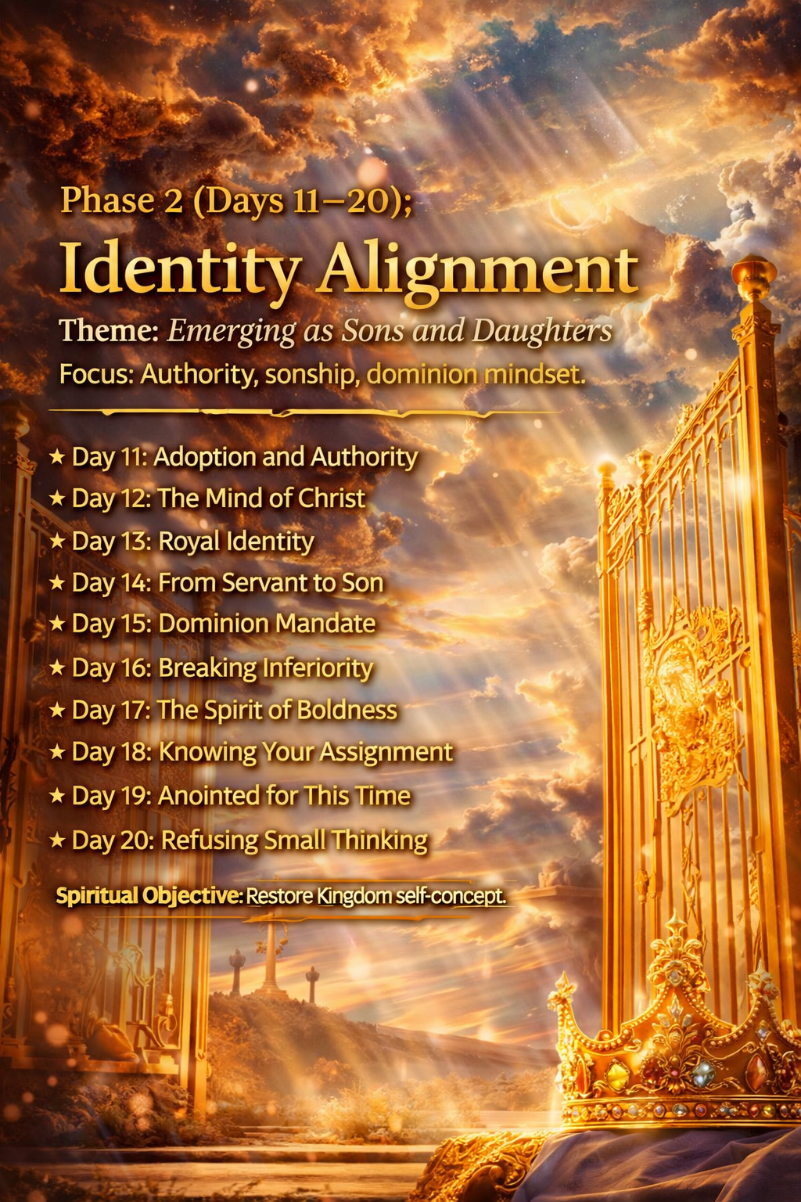

Phase 2 — Identity Alignment

Days 11–20: Becoming Who God Says You Are
Focus: Understanding sonship, authority, and Kingdom identity.
Objective: Establish a Kingdom self-concept rooted in Christ.

Day 11 — Adopted Into God’s Family

Theme Scripture
Romans 8:15
"You received the Spirit of adoption by whom we cry out, 'Abba, Father.'"

Reflection
Identity begins with relationship. Before believers are called to accomplish anything for God, they are first invited into relationship with Him. Through Christ, we are not merely forgiven sinners—we are adopted sons and daughters of God. This transformation moves us from spiritual separation into belonging within God’s family.
Paul emphasizes this truth when he writes that believers have received the “Spirit of adoption.” Adoption in biblical times carried profound legal and relational significance. Once adopted, a child gained full rights within the family. In the same way, those who belong to Christ are granted full access to God’s presence and promises. “The Spirit Himself bears witness with our spirit that we are children of God” (Romans 8:16).
This identity reshapes how we approach God. Instead of approaching Him with fear or distance, we come confidently as children who are deeply loved. Hebrews reminds us, “Let us therefore come boldly to the throne of grace” (Hebrews 4:16). Our prayers, our faith, and our obedience flow from the security of knowing we belong to Him.
Spiritual alignment begins when we embrace this truth fully. When we understand that we are God’s children, insecurity begins to dissolve. We no longer measure our worth by human standards but by the love and acceptance God has already given us through Christ.

Declaration
I declare that I am a child of God, adopted through the work of Jesus Christ. I belong to the family of God and live with the confidence that my Heavenly Father loves, guides, and provides for me. My identity is secure in Him, and I approach His presence with faith, gratitude, and boldness.

Prayer
Heavenly Father, thank You for adopting me into Your family through Christ. Help me live with the confidence that I belong to You. Remove every insecurity that prevents me from embracing this truth, and teach me to walk daily as Your beloved child. In Jesus’ name, Amen.

Daily Direction
• Read Romans 8:14–17 and reflect on your identity as God’s child.
• Thank God for the privilege of being part of His family.
• Write down three ways God has demonstrated His love for you.
• Approach God in prayer today with the confidence of a beloved child.

Day 12 — Renewing Your Identity in Christ

Theme Scripture
2 Corinthians 5:17
"If anyone is in Christ, he is a new creation."

Reflection
One of the most transformative truths in Scripture is that believers are made new through Christ. The apostle Paul describes this change as becoming a “new creation.” This means our past does not define our identity; our relationship with Christ does.
Many people struggle to embrace this truth fully. Memories of past mistakes or failures can create a lingering sense of unworthiness. Yet Scripture reminds us that Christ’s work on the cross completely changes our spiritual standing. “There is therefore now no condemnation for those who are in Christ Jesus” (Romans 8:1).
Renewing our identity requires aligning our thinking with God’s truth rather than our past experiences. When God forgives, He removes our sins completely. As Psalm 103:12 declares, “As far as the east is from the west, so far has He removed our transgressions from us.” This means our identity is not anchored in what we have done but in what Christ has accomplished.
Spiritual growth begins when we learn to see ourselves the way God sees us. Through Christ we are forgiven, redeemed, and restored. As we internalize this truth, our confidence grows and our ability to walk in God’s purpose becomes clearer.

Declaration
I declare that I am a new creation in Christ. My past no longer defines my identity, and every accusation against me has been removed through the work of Jesus. I embrace the new life God has given me and walk forward with confidence in His transforming grace.

Prayer
Father, help me fully embrace the identity You have given me through Christ. Remove every lie that tells me I am defined by my past, and renew my thinking with the truth of Your Word. Teach me to live confidently as a new creation in You. In Jesus’ name, Amen.

Daily Direction
• Reflect on 2 Corinthians 5:17 and write it in your own words.
• Thank God for the forgiveness and new life He has given you.
• Replace one negative self-perception with a truth from Scripture.
• Spend time praising God for His redeeming grace.

Day 13 — Called and Chosen

Theme Scripture
1 Peter 2:9
"You are a chosen generation, a royal priesthood, a holy nation, His own special people."

Reflection
God’s calling begins with His choice. Scripture reveals that believers are not only forgiven but also chosen for a purpose. Peter describes followers of Christ as a “chosen generation” and a “royal priesthood.” These words convey both privilege and responsibility.
Being chosen does not mean superiority—it means divine assignment. God calls His people to represent His character and reflect His truth in the world. Jesus affirmed this truth when He said, “You did not choose Me, but I chose you and appointed you that you should go and bear fruit” (John 15:16).
Understanding this calling strengthens our sense of purpose. When believers recognize that God intentionally chose them, feelings of insignificance begin to fade. Ephesians reminds us that we were chosen in Christ even before the foundation of the world (Ephesians 1:4). Our lives are not accidental; they are part of God’s unfolding plan.
Living with this awareness transforms how we approach daily life. Our words, decisions, and actions become opportunities to reflect the character of Christ. Every believer carries the privilege of representing God’s love and truth wherever they go.

Declaration
I declare that I am chosen by God and called to live according to His purpose. My life has meaning and direction because I belong to Him. I walk confidently in the identity He has given me, knowing that He has appointed me to bear fruit that reflects His Kingdom.

Prayer
Lord, thank You for choosing me and giving my life purpose. Help me walk faithfully in the calling You have placed upon me. Let my life reflect Your love, truth, and wisdom so that others may see Your goodness through me. Amen.

Daily Direction
• Read 1 Peter 2:9 slowly and reflect on its meaning.
• Ask God to reveal ways you can represent Him today.
• Write down areas where you sense God calling you to grow.
• Thank God for choosing you for His purpose.

Day 14 — Royal Identity

Theme Scripture
Revelation 1:6
"He has made us kings and priests to His God and Father."

Reflection
The identity of believers extends beyond forgiveness—it includes spiritual authority. Scripture describes followers of Christ as both kings and priests. This imagery highlights the balance between representing God before people and representing people before God.
Priests in the Old Testament were responsible for maintaining a connection between God and the community. Through Christ, believers now have direct access to God and are called to intercede for others. Hebrews explains that Jesus opened the way for believers to approach God confidently (Hebrews 10:19–22).
The concept of kingship represents authority and responsibility. In Christ, believers are given the authority to influence their environment through prayer, wisdom, and righteous living. Jesus taught His disciples to pray for God’s Kingdom to come and His will to be done on earth (Matthew 6:10).
When believers understand their royal identity, their perspective changes. Instead of living reactively to circumstances, they begin living intentionally according to God’s purpose. Their prayers become bold, their faith becomes active, and their influence begins to reflect Kingdom values.

Declaration
I declare that I am part of God’s royal priesthood. Through Christ I have access to God’s presence and the authority to represent His Kingdom in the earth. I live with purpose, wisdom, and spiritual confidence as I fulfill the role God has entrusted to me.

Prayer
Father, help me understand the authority and responsibility that comes with my identity in Christ. Teach me to represent Your Kingdom faithfully and to use the influence You have given me for Your glory. In Jesus’ name, Amen.

Daily Direction
• Reflect on Revelation 1:6 and what it means to be part of God’s Kingdom.
• Spend time praying for others today.
• Ask God to help you represent Him in your daily interactions.
• Commit to living in a way that reflects Kingdom values.

Day 15 — Breaking the Spirit of Inferiority

Theme Scripture
Psalm 139:14
"I will praise You, for I am fearfully and wonderfully made."

Reflection
Many believers struggle with feelings of inadequacy and comparison. Cultural expectations and personal experiences can create the impression that we are not capable, not worthy, or not significant. Yet Scripture consistently challenges these assumptions by reminding us that God intentionally created each person with purpose.
David celebrated this truth in Psalm 139, acknowledging that every detail of his life was carefully designed by God. This means our abilities, personalities, and life experiences all contribute to the unique role God has prepared for us. Inferiority loses its power when we understand that our value comes from God’s intentional design.
The apostle Paul addressed similar concerns when he wrote that believers are God’s workmanship, created for good works prepared in advance (Ephesians 2:10). Our purpose is not based on comparison with others but on obedience to God’s unique calling.
When believers embrace their God-given identity, they become free from the burden of comparison. Instead of measuring themselves against others, they focus on faithfully fulfilling the purpose God has entrusted to them.

Declaration
I declare that I am created intentionally by God and equipped for the purpose He has given me. Inferiority and comparison have no authority over my life. I embrace the identity and calling God has placed upon me and walk confidently in the unique role He has prepared for me.

Prayer
Father, remove every lie that causes me to doubt my value or purpose. Help me see myself through Your eyes and recognize the gifts and abilities You have placed within me. Strengthen my confidence so that I may walk faithfully in the calling You have given me. Amen.

Daily Direction
• Reflect on Psalm 139:13–16.
• Write down three strengths or gifts God has given you.
• Thank God for the unique role He has given you.
• Avoid comparing yourself to others today.

Day 16 — The Spirit of Boldness

Theme Scripture
2 Timothy 1:7
"For God has not given us a spirit of fear, but of power and of love and of a sound mind."

Reflection
Fear often becomes the greatest obstacle to living fully in our God-given identity. When believers allow fear to shape their decisions, they may hesitate to pursue opportunities, share their faith, or walk boldly in their calling. Yet Scripture clearly states that fear does not originate from God. Instead, He equips His people with power, love, and sound judgment.
The early disciples experienced this transformation firsthand. Before the resurrection and the outpouring of the Holy Spirit, many of them struggled with fear and uncertainty. After encountering the risen Christ and receiving the Spirit’s empowerment, they spoke boldly about their faith. Acts 4:31 describes how they were filled with the Holy Spirit and “spoke the word of God with boldness.”
Boldness does not mean arrogance or self-confidence alone; it is confidence rooted in God’s presence and promises. When believers understand their identity in Christ, fear loses its influence. Joshua experienced this truth when God reminded him, “Be strong and courageous… for the Lord your God is with you wherever you go” (Joshua 1:9).
Identity alignment includes embracing the courage that comes from trusting God. When we remember that He walks with us, we can move forward with faith rather than hesitation. Boldness becomes the natural result of knowing who we are and whose we are.

Declaration
I declare that I walk in the boldness God has given me. Fear does not control my decisions, and uncertainty does not limit my faith. Through the power of the Holy Spirit, I move forward with courage, wisdom, and confidence, trusting that God is guiding every step of my life.

Prayer
Heavenly Father, remove every fear that attempts to hinder my faith and my purpose. Fill me with courage and confidence as I walk in the identity You have given me. Help me trust Your presence and move forward boldly in obedience to Your will. In Jesus’ name, Amen.

Daily Direction
• Reflect on an area where fear has limited your growth.
• Pray for courage and wisdom in that area.
• Read Joshua 1:6–9 and meditate on God’s promise of presence.
• Take one small step today that demonstrates faith instead of fear.

Day 17 — Discovering Your Assignment

Theme Scripture
Ephesians 2:10
"For we are His workmanship, created in Christ Jesus for good works, which God prepared beforehand that we should walk in them."

Reflection
Identity and purpose are closely connected. When believers understand who they are in Christ, they begin to recognize the assignments God has placed before them. Scripture reminds us that our lives are not random or accidental. God intentionally designed each person with specific gifts, abilities, and opportunities to serve His Kingdom.
Paul describes believers as God’s workmanship. The Greek word used here implies a masterpiece—something carefully designed and intentionally created. This means every believer carries a unique role within God’s plan. Our talents, experiences, and passions can all become tools for fulfilling the work God has prepared.
Discovering one’s assignment often begins with faithful obedience in small things. Jesus explained this principle when He said, “He who is faithful in what is least is faithful also in much” (Luke 16:10). As believers demonstrate faithfulness in daily responsibilities, God often reveals larger opportunities for influence and service.
Understanding our assignment brings clarity and motivation. Instead of drifting through life without direction, we begin to see our daily actions as part of a larger purpose. Every act of kindness, every word of encouragement, and every opportunity to serve becomes a reflection of God’s work through us.

Declaration
I declare that my life has purpose and direction because God has created me intentionally. I embrace the assignments He places before me and commit to serving Him faithfully. My gifts and opportunities will be used to reflect His love, wisdom, and truth in the world.

Prayer
Father, reveal the purpose You have prepared for my life. Help me recognize the opportunities You place before me and give me the wisdom and courage to respond faithfully. May my life reflect Your work and bring glory to Your name. Amen.

Daily Direction
• Reflect on your strengths, passions, and experiences.
• Ask God how these can be used to serve others.
• Pray for clarity regarding your purpose.
• Take one step today toward fulfilling an opportunity to serve.

Day 18 — Walking in Spiritual Authority

Theme Scripture
Luke 10:19
"Behold, I give you the authority… over all the power of the enemy."

Reflection
Spiritual authority is a vital aspect of identity in Christ. Many believers struggle to recognize the authority God has entrusted to them. Yet Jesus clearly affirmed that His followers have been given authority to stand against spiritual opposition and live in victory.
Authority in the Kingdom of God is not about personal status or control—it is about representing Christ’s victory. Through His death and resurrection, Jesus defeated the powers of darkness. Colossians 2:15 explains that He disarmed spiritual rulers and authorities, triumphing over them through the cross.
Believers participate in that victory by living in alignment with Christ. When we walk in obedience and faith, we exercise spiritual authority through prayer, truth, and righteous living. James reminds us that when we submit to God and resist the devil, the enemy must flee (James 4:7).
Understanding spiritual authority strengthens our confidence in facing life’s challenges. Instead of feeling overwhelmed by circumstances, we remember that Christ’s power is greater than any opposition. Our identity in Him equips us to stand firm in faith and live with spiritual confidence.

Declaration
I declare that I walk in the spiritual authority given to me through Christ. I stand firm in faith, knowing that the power of God is greater than any opposition. Through prayer, obedience, and trust in God’s Word, I live confidently in the victory Christ has secured.

Prayer
Lord, help me understand the authority I have through Christ. Teach me to walk in faith, wisdom, and obedience so that my life reflects the victory of the cross. Strengthen me to stand firm against every challenge with confidence in Your power. Amen.

Daily Direction
• Read Luke 10:17–20 and reflect on the authority given by Christ.
• Pray confidently about a challenge you are facing.
• Declare God’s promises over your situation.
• Thank God for the victory available through Christ.

Day 19 — Aligning with God’s Purpose

Theme Scripture
Proverbs 3:5–6
"Trust in the Lord with all your heart… and He shall direct your paths."

Reflection
Identity alignment involves trusting God to guide the direction of our lives. Many people attempt to control their future through personal effort alone, yet Scripture encourages believers to rely on God’s wisdom rather than their own understanding.
Trusting God requires humility and faith. It means acknowledging that God’s perspective is greater than our own. Isaiah reminds us that God’s thoughts and ways are higher than ours (Isaiah 55:8–9). When we surrender our plans to Him, we position ourselves to experience guidance that exceeds our expectations.
Divine alignment often unfolds gradually. As believers remain faithful in prayer and obedience, God directs their steps. Psalm 37:23 declares, “The steps of a good man are ordered by the Lord.” This means our journey does not depend solely on our ability to predict the future but on our willingness to follow God’s leading.
When our lives align with God’s purpose, we experience greater peace and clarity. Instead of striving to control outcomes, we trust the One who sees the entire path ahead.

Declaration
I declare that my life is aligned with the purposes of God. I trust His wisdom, follow His guidance, and walk confidently in the direction He provides. My steps are ordered by the Lord, and I rest in the assurance that He is directing my path.

Prayer
Father, help me trust Your guidance completely. Teach me to rely on Your wisdom rather than my own understanding. Direct my steps and align my life with the purpose You have prepared for me. In Jesus’ name, Amen.

Daily Direction
• Pray about a decision or direction in your life.
• Reflect on Proverbs 3:5–6.
• Surrender your plans to God in prayer.
• Take one step today that aligns with God’s guidance.

Day 20 — Refusing Small Thinking

Theme Scripture
Ephesians 3:20
"Now to Him who is able to do exceedingly abundantly above all that we ask or think."

Reflection
One of the greatest barriers to spiritual growth is limited thinking. When believers underestimate what God can accomplish through their lives, they may settle for less than the purpose He intends. Yet Scripture consistently reminds us that God’s plans exceed human expectations.
Paul describes God as able to do far more than we can imagine. This truth challenges believers to expand their perspective and trust that God’s power can accomplish extraordinary things. Jeremiah 29:11 reminds us that God’s plans are filled with hope and a future beyond our present understanding.
Refusing small thinking does not mean pursuing personal ambition; it means believing that God’s purposes are greater than our limitations. When believers trust God’s power, they begin to pray with greater faith, serve with greater commitment, and pursue opportunities with renewed courage.
Jesus often encouraged His followers to think beyond natural limitations. When the disciples doubted how thousands could be fed with limited resources, Jesus demonstrated that God’s provision surpasses human calculation (Matthew 14:17–21). Faith invites believers to expect more from God because His power is unlimited.

Declaration
I declare that my thinking aligns with the greatness of God’s power. I refuse to limit what God can accomplish through my life. I trust that He is able to do more than I can imagine, and I walk forward with faith in His promises and purpose.

Prayer
Heavenly Father, expand my vision and strengthen my faith so that I may believe in the fullness of what You can accomplish. Remove every limiting mindset and help me trust Your power to work through my life for Your glory. In Jesus’ name, Amen.

Daily Direction
• Reflect on Ephesians 3:20 and its meaning for your life.
• Identify an area where you may be limiting your expectations of God.
• Pray boldly about a vision or goal God has placed in your heart.
• Take a step today that demonstrates faith in God’s greater plan

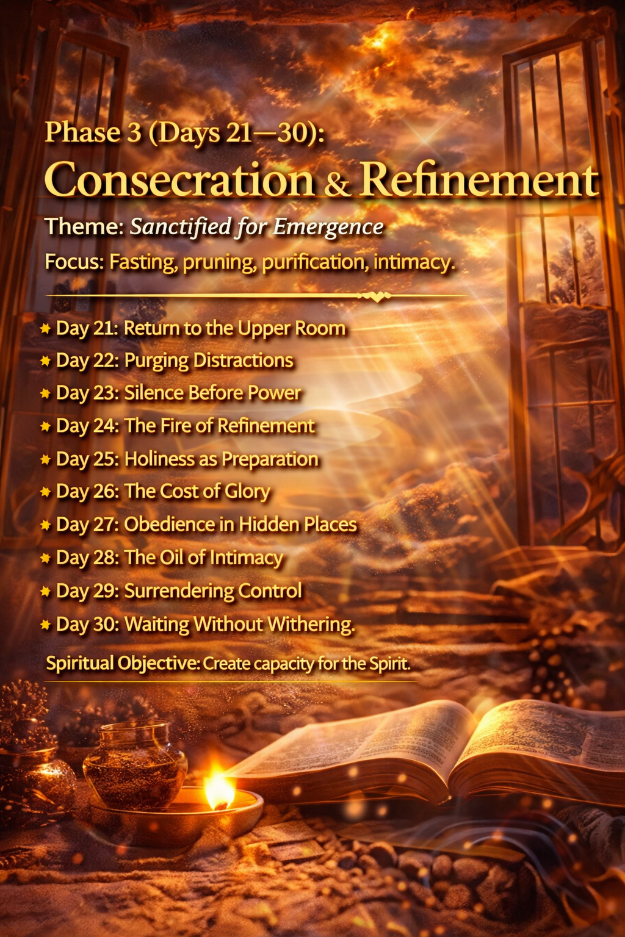

Phase 3 — Consecration & Refinement

Days 21–30: Prepared in the Secret Place
Focus: Spiritual purification, surrender, and intimacy with God.
Objective: Increase spiritual capacity for God’s presence and prepare the heart for empowerment.

Day 21 — Return to the Upper Room

Theme Scripture
Acts 1:13–14
"These all continued with one accord in prayer and supplication."

Reflection
After Jesus ascended into heaven, the disciples did not immediately rush into ministry. Instead, they gathered in the Upper Room in obedience to His instruction to wait for the promise of the Holy Spirit. Though they had already witnessed the resurrection and received the commission, they understood that spiritual preparation was necessary before public ministry could begin.
The Upper Room represents a posture of humility and expectancy. It was a place where believers gathered together in prayer, unity, and surrender. In that environment of devotion, their hearts were being aligned with God’s purposes. They understood that the power required for their assignment would come from God, not from their own ability.
Scripture consistently reveals the importance of waiting on God. Isaiah declared, “But those who wait on the Lord shall renew their strength; they shall mount up with wings like eagles” (Isaiah 40:31). Waiting is not inactivity; it is intentional dependence on God’s timing and preparation. During these moments of waiting, God strengthens faith, clarifies vision, and deepens spiritual maturity.
Entering the Upper Room spiritually means stepping away from distractions and intentionally seeking God’s presence. It is a place where prayer becomes consistent, where the heart becomes sensitive to God’s voice, and where believers prepare themselves for the next move of God in their lives.

Declaration
I declare that I am entering the Upper Room of spiritual preparation. My heart is aligned with God’s purposes, and my spirit is attentive to His voice. As I seek Him in prayer and humility, He is strengthening me, preparing me, and positioning me for the next season of my life.

Prayer
Heavenly Father, draw me deeper into Your presence. Help me embrace the posture of the Upper Room—one of prayer, unity, humility, and expectation. Prepare my heart for the work You are about to do in my life and fill me with renewed strength as I wait on You.

Daily Direction
• Spend extended time in prayer today, focusing on listening to God.
• Read Acts 1:4–8 and reflect on the promise of the Holy Spirit.
• Identify distractions that prevent deeper spiritual focus.
• Ask God to prepare your heart for the next season.

Day 22 — Removing Spiritual Weights

Theme Scripture
Hebrews 12:1
"Let us lay aside every weight, and the sin which so easily ensnares us."

Reflection
Spiritual growth often requires releasing what slows us down. Hebrews encourages believers to lay aside both sin and “weights”—things that may not necessarily be sinful but still hinder spiritual progress. These weights can include distractions, unhealthy habits, misplaced priorities, or relationships that pull us away from God’s purpose.
Jesus warned about the subtle danger of spiritual distraction in the parable of the sower. He explained that the cares of life and the pursuit of worldly desires can choke spiritual growth, preventing the Word from producing fruit (Mark 4:18–19). When our attention becomes divided, our spiritual vitality can gradually diminish.
Consecration invites believers to evaluate their priorities and make adjustments that support spiritual growth. Paul described this process as running a race with endurance, removing anything that restricts movement. When unnecessary weights are removed, our spiritual focus sharpens and our capacity to pursue God increases.
God’s desire is not to burden believers with rules but to free them to run the race of faith with clarity and purpose. As distractions are removed, spiritual energy increases, and believers experience greater focus, joy, and effectiveness in their walk with God.

Declaration
I declare that every weight that hinders my spiritual growth is being removed. My life is aligned with God’s priorities, and my heart is fully devoted to pursuing His presence and purpose.

Prayer
Lord, reveal anything in my life that slows my spiritual progress. Give me wisdom and courage to release every weight that distracts me from Your purpose. Help me run the race of faith with focus, perseverance, and joy.

Daily Direction
• Ask God to reveal any distractions affecting your spiritual focus.
• Read Hebrews 12:1–3 and reflect on perseverance in faith.
• Remove or reduce one activity that competes with time with God.
• Recommit to a daily rhythm of prayer and Scripture.

Day 23 — The Discipline of Stillness

Theme Scripture
Psalm 46:10
"Be still, and know that I am God."

Reflection
In today’s fast-paced world, stillness can feel unfamiliar. Yet throughout Scripture, God invites His people to pause, quiet their hearts, and recognize His presence. Stillness is not merely the absence of activity—it is a spiritual discipline that allows believers to become attentive to God’s voice.
The prophet Elijah experienced this truth during a moment of discouragement. As he waited on Mount Horeb, he witnessed powerful natural events—wind, earthquake, and fire. Yet Scripture tells us that God’s voice came in a gentle whisper (1 Kings 19:11–12). Elijah’s encounter reminds us that God’s guidance often emerges in moments of quiet attentiveness rather than constant activity.

Stillness also restores spiritual perspective. David expressed this posture when he wrote, “My soul waits silently for God alone; from Him comes my salvation” (Psalm 62:1). When believers quiet their hearts before God, anxiety begins to fade and confidence in His presence grows.
Practicing stillness creates space for reflection, prayer, and spiritual renewal. As we intentionally slow down and seek God’s presence, we often discover renewed clarity, deeper peace, and a greater awareness of His guidance in our lives.

Declaration
I declare that my heart is attentive to the presence of God. In moments of stillness, I recognize His voice, receive His wisdom, and rest in the peace that comes from knowing He is in control.

Prayer
Father, teach me the discipline of stillness. Quiet my heart and remove the noise that distracts me from hearing Your voice. Help me recognize Your presence and trust Your guidance as I wait before You.

Daily Direction
• Spend 10–15 minutes today in silent prayer before God.
• Reflect on Psalm 46 and write down what it reveals about God’s character.
• Reduce unnecessary noise or distractions for part of the day.
• Listen attentively for any insight or guidance from God.

Day 24 — The Fire of Refinement

Theme Scripture
Malachi 3:3
"He will sit as a refiner and purifier of silver."

Reflection
God often prepares His people through seasons of refinement. Refinement removes impurities so that what remains reflects greater purity and strength. In the same way that precious metals must pass through intense heat to remove impurities, God sometimes allows challenging circumstances to shape and mature our faith.
Scripture repeatedly demonstrates that refinement precedes elevation. Joseph endured betrayal, slavery, and imprisonment before rising to leadership in Egypt (Genesis 50:20). David spent years fleeing from Saul before becoming king (1 Samuel 24). Even Jesus experienced a season of testing in the wilderness before beginning His public ministry (Luke 4:1–14).
Refinement is not punishment—it is preparation. Peter explained that trials test the genuineness of our faith and produce spiritual maturity (1 Peter 1:6–7). Through these experiences, believers develop endurance, humility, and deeper reliance on God.
When we understand God’s refining process, we begin to trust His work even when it feels uncomfortable. Every season of testing carries the potential to strengthen our character and prepare us for the greater purpose God has planned.

Declaration
I declare that God’s refining work in my life is producing strength, maturity, and deeper faith. Every challenge I face is shaping my character and preparing me for the purpose God has prepared for me. I trust His process and embrace His work in my life.

Prayer
Heavenly Father, help me trust Your refining work in my life. Purify my heart, strengthen my faith, and shape my character so that I reflect Your wisdom and holiness. Give me perseverance through every challenge and confidence in Your purpose.

Daily Direction
• Reflect on a past challenge that strengthened your faith.
• Read 1 Peter 1:6–7 and meditate on the purpose of testing.
• Ask God what He may be refining in your life.
• Thank Him for using every season to shape your character.

Day 25 — Midpoint Reset: Realigning the Heart

Theme Scripture
Psalm 51:10
"Create in me a clean heart, O God, and renew a steadfast spirit within me."

Reflection
Every meaningful journey benefits from moments of reflection and recalibration. At this midpoint of the consecration journey, it is important to pause and evaluate what God has been revealing. Spiritual growth often includes moments of progress, moments of conviction, and moments of renewal.
David’s prayer in Psalm 51 captures the essence of spiritual reset. After recognizing his need for renewal, he asked God not merely to change his circumstances but to transform his heart. David understood that true change begins internally. When the heart is aligned with God, outward actions naturally follow.
Spiritual resets create space for honesty and humility. Lamentations reminds us that “the steadfast love of the Lord never ceases… His mercies are new every morning” (Lamentations 3:22–23). God continually offers fresh opportunities for renewal and recommitment. No matter how the journey has unfolded so far, His grace provides a new beginning.
This midpoint invites you to examine your spiritual focus. What has God been teaching you during these days? What distractions or patterns still need to be released? As you bring these questions before God, He renews your strength and realigns your heart for the remainder of the journey.

Declaration
I declare that my heart is being renewed and realigned with the purposes of God. I receive His mercy, His correction, and His grace as I continue this journey. My spirit is steadfast, my focus is renewed, and my life is committed to walking faithfully with Him.

Prayer
Father, examine my heart and renew my spirit. Remove anything within me that distracts me from Your purpose. Restore my passion for Your presence and strengthen my commitment to follow You wholeheartedly.

Daily Direction
• Reflect on the first 24 days of this journey.
• Write down one lesson God has taught you.
• Pray Psalm 51 slowly and sincerely.
• Renew your commitment to complete the remaining days faithfully.

Day 26 — Surrendering Control

Theme Scripture
Luke 9:23
"If anyone desires to come after Me, let him deny himself, and take up his cross daily, and follow Me."

Reflection
Surrender is a central element of spiritual growth. While the world often celebrates independence and control, Jesus teaches that true discipleship involves surrendering our will to God’s direction. This surrender is not a loss of freedom but a pathway to greater purpose.
When believers attempt to control every outcome, they often carry unnecessary stress and uncertainty. Proverbs reminds us, “Trust in the Lord with all your heart, and lean not on your own understanding” (Proverbs 3:5–6). Trusting God means acknowledging that His wisdom exceeds our limited perspective.
Surrender allows God to guide our decisions and shape our path. Jesus demonstrated this posture in the Garden of Gethsemane when He prayed, “Not My will, but Yours be done” (Luke 22:42). His willingness to surrender resulted in the fulfillment of God’s redemptive plan.
When believers release control, they create space for God’s guidance and provision. Surrender becomes an act of faith that acknowledges God’s sovereignty and trustworthiness.

Declaration
I declare that I surrender my plans, expectations, and desires to the will of God. I trust His wisdom above my own understanding and follow His direction with faith and humility.

Prayer
Lord, teach me to surrender every part of my life to Your will. Help me release the need to control outcomes and trust Your guidance completely. Align my desires with Your purpose.

Daily Direction
• Identify an area where you struggle to surrender control.
• Pray specifically about that area today.
• Reflect on Proverbs 3:5–6.
• Take a step of faith by trusting God with a decision.

Day 27 — Strength in the Secret Place

Theme Scripture
Matthew 6:6
"When you pray, go into your room… and your Father who sees in secret will reward you openly."

Reflection
Many of the most significant moments of spiritual preparation occur in hidden places. Before public ministry, Jesus often withdrew to solitary places to pray (Luke 5:16). These moments of private devotion strengthened His relationship with the Father and prepared Him for the demands of His mission.
The secret place represents intimacy with God. It is where believers cultivate a personal relationship with Him through prayer, reflection, and worship. In these quiet moments, faith deepens and spiritual clarity grows.
The world often values visible success, but God places great importance on unseen devotion. Jesus explained that what happens in the secret place eventually produces fruit in the open. Spiritual authority and influence are built through consistent private communion with God.
As believers prioritize time with God, they develop spiritual resilience. The secret place becomes a source of strength, guidance, and renewal that sustains them through every season.

Declaration
I declare that my time with God in the secret place strengthens my faith and prepares me for greater purpose. My relationship with Him is growing deeper and stronger each day.

Prayer
Father, draw me into deeper intimacy with You. Help me value the quiet moments of prayer and reflection where my faith is strengthened and my heart is aligned with Your will.

Daily Direction
• Set aside intentional time for prayer today.
• Reflect on Matthew 6:5–8.
• Journal insights from your time with God.
• Prioritize consistency in daily devotion.

Day 28 — Cultivating Spiritual Hunger

Theme Scripture
Matthew 5:6
"Blessed are those who hunger and thirst for righteousness, for they shall be filled."

Reflection
Spiritual hunger drives transformation. Those who hunger for God pursue Him with passion and sincerity. This desire grows as believers experience His presence and recognize the depth of His wisdom and love.
Throughout Scripture, individuals who sought God earnestly encountered profound transformation. David expressed this longing when he wrote, “O God, You are my God; early will I seek You; my soul thirsts for You” (Psalm 63:1). His hunger for God shaped his leadership and faith.
Hunger also produces spiritual growth. As believers prioritize God’s presence, their understanding deepens and their faith becomes stronger. Jeremiah recorded God’s promise: “You will seek Me and find Me when you search for Me with all your heart” (Jeremiah 29:13).
When believers cultivate spiritual hunger, they discover that God always responds to sincere pursuit. His presence satisfies the deepest needs of the human heart.

Declaration
I declare that my heart longs for the presence of God. My desire for His truth and righteousness grows stronger each day as I pursue Him wholeheartedly.

Prayer
Lord, increase my hunger for Your presence and Your Word. Let my heart seek You continually and find satisfaction in Your truth and guidance.

Daily Direction
• Read Matthew 5:1–12 and reflect on spiritual hunger.
• Spend time worshiping God today.
• Identify ways to prioritize spiritual growth.
• Seek God intentionally through prayer and Scripture.

Day 29 — Preparing the Vessel

Theme Scripture
2 Timothy 2:21
"If anyone cleanses himself… he will be a vessel for honor, sanctified and useful for the Master."

Reflection
Preparation determines usefulness. Paul uses the imagery of vessels to illustrate how believers can become instruments for God’s work. Just as a vessel must be clean and ready to be used effectively, believers must prepare their hearts and lives to serve God faithfully.
Consecration involves aligning our lives with God’s character and purpose. This includes cultivating integrity, humility, and obedience. As believers grow in these qualities, they become more effective in representing God’s Kingdom.
Preparation also includes spiritual discipline. Prayer, study of Scripture, and consistent obedience strengthen our capacity to serve. Paul encouraged Timothy to present himself as a worker approved by God, accurately handling the Word of truth (2 Timothy 2:15).
When believers allow God to shape their character, they become vessels prepared for meaningful service. God delights in using lives that are surrendered, faithful, and aligned with His purposes.

Declaration
I declare that my life is being prepared as a vessel for God’s work. My heart is consecrated, my character is being shaped, and my life is ready to be used for His glory.

Prayer
Father, prepare my heart and life for the assignments You have planned. Cleanse my motives, strengthen my character, and help me live in a way that honors You.

Daily Direction
• Reflect on 2 Timothy 2:20–21.
• Ask God to reveal areas needing spiritual growth.
• Commit to strengthening one spiritual discipline.
• Pray for readiness to serve God’s purpose.

Day 30 — Strengthened for the Next Season

Theme Scripture
Isaiah 40:31
"Those who wait on the Lord shall renew their strength."

Reflection
Seasons of waiting and consecration are never wasted. God uses these moments to strengthen faith, deepen character, and prepare believers for the assignments ahead. Isaiah reminds us that those who wait on the Lord receive renewed strength for the journey.
Waiting on God does not mean passivity; it involves active trust and expectation. During these seasons, God aligns our priorities and equips us with the spiritual endurance needed to fulfill His purpose.
The promise of renewed strength reveals God’s faithfulness. As believers continue seeking Him, He provides the energy, wisdom, and courage required for the next stage of their journey. This preparation becomes the foundation for greater responsibility and influence.
As this phase concludes, believers move forward with renewed clarity and confidence. God has been shaping their hearts and preparing them for what lies ahead. The next phase will shift from inner preparation to outward authority.

Declaration
I declare that my strength is renewed through the presence of the Lord. I am prepared for the next season of purpose and walk forward with confidence in His guidance and power.

Prayer
Father, thank You for strengthening me through this season of consecration. Continue to guide my steps and prepare me for the assignments ahead. I trust Your timing and Your purpose.

Daily Direction
• Reflect on Isaiah 40:31.
• Thank God for the growth you have experienced during this phase.
• Prepare your heart for the next stage of the journey.
• Ask God for renewed strength and clarity.

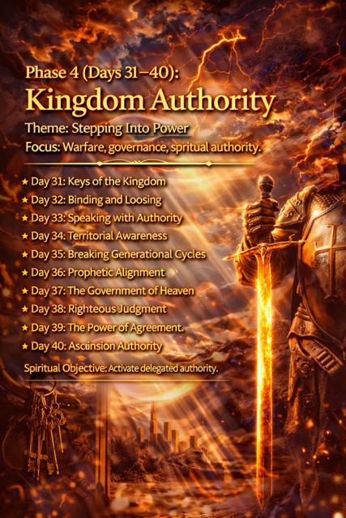Phase 4 — Kingdom Authority

Days 31–40: Walking in the Authority of the Risen Christ
Focus: Spiritual authority, prayer power, and Kingdom influence.
Objective: Activate the authority believers possess in Christ and prepare them to operate in Spirit-empowered living.

Day 31 — The Authority of the Risen Christ

Theme Scripture
Matthew 28:18
"And Jesus came and spoke to them, saying, ‘All authority has been given to Me in heaven and on earth.’"

Reflection
The resurrection of Jesus Christ did more than confirm His identity as the Son of God—it established His absolute authority over all creation. After conquering death and rising from the grave, Jesus declared that all authority in heaven and on earth had been entrusted to Him. This proclamation was not merely theological; it carried profound implications for the mission of His followers.
Christ’s authority extends over every realm of existence. Paul describes this reality in Ephesians when he explains that God raised Christ from the dead and seated Him at His right hand, “far above all principality and power and might and dominion” (Ephesians 1:20–21). No spiritual force, earthly power, or circumstance exists outside the scope of His rule.
This authority becomes the foundation for the believer’s confidence. When Jesus commissioned His disciples to go into the world and make disciples, He did so on the basis of the authority He possessed. Their mission was not dependent on their own strength but on the authority of the risen Christ working through them.
Recognizing Christ’s authority transforms the way believers approach life. Challenges may arise, and uncertainty may appear, but faith remains anchored in the truth that the One who holds all authority walks with us. Our confidence is not rooted in our abilities but in His sovereign power and presence.

Declaration
I declare that Jesus Christ reigns with all authority in heaven and on earth. His victory over death secures my confidence and strengthens my faith. Because I belong to Him, I walk in the assurance that His authority guides my life and empowers my purpose.

Prayer
Lord Jesus, I honor You as the risen King who reigns with all authority. Help me trust Your power in every circumstance and live with confidence in Your sovereignty. Strengthen my faith so that I may walk boldly in the purpose You have prepared for me.

Daily Direction
• Reflect on Matthew 28:18–20 and the authority of Christ.
• Thank God for His sovereignty over every situation in your life.
• Pray about a challenge while acknowledging Christ’s authority.
• Walk forward today with renewed confidence in His power.

Day 32 — Authority Entrusted to Believers

Theme Scripture
Luke 10:19
"Behold, I give you the authority to trample on serpents and scorpions, and over all the power of the enemy."

Reflection
Jesus did not intend for His followers to live powerless lives. Throughout His ministry, He demonstrated spiritual authority and then entrusted His disciples with the same authority to advance the Kingdom of God. This authority was not based on personal strength but on the authority of Christ working through them.
In Luke 10, Jesus sent His disciples ahead to proclaim the message of the Kingdom and minister to those in need. When they returned, they rejoiced that even spiritual forces responded to the authority of Christ’s name. Their experience revealed that the authority Jesus granted was real and effective.
The early church continued to walk in this authority after the resurrection. In Acts 3, Peter encountered a man who had been lame since birth. Instead of offering sympathy alone, he declared, “In the name of Jesus Christ of Nazareth, rise up and walk” (Acts 3:6). The miracle that followed demonstrated the power of Christ working through a faithful servant.
Understanding spiritual authority transforms the believer’s perspective. Prayer becomes more confident, faith becomes more active, and obedience becomes more intentional. Authority is not exercised for personal status but for advancing God’s purposes and serving others with compassion and truth.

Declaration
I declare that the authority of Christ is at work in my life. Through faith in His name, I walk with confidence and boldness, trusting that His power enables me to overcome challenges and fulfill His purpose.

Prayer
Heavenly Father, help me understand the authority You have entrusted to believers through Christ. Teach me to walk in humility, faith, and obedience as I rely on Your power to guide and strengthen my life.

Daily Direction
• Read Luke 10:17–20 and reflect on the authority Jesus gives His followers.
• Pray confidently about a situation that requires God’s intervention.
• Speak words of faith and encouragement over your circumstances.
• Thank God for the authority and victory found in Christ.

Day 33 — The Power of Prayer

Theme Scripture
James 5:16
"The effective, fervent prayer of a righteous man avails much."

Reflection
Prayer is one of the most powerful expressions of Kingdom authority available to believers. Through prayer, we are not merely expressing hope or desire—we are entering into partnership with God’s purposes on the earth. Prayer aligns our hearts with His will and invites His power into the circumstances of our lives. James reminds us that fervent and faithful prayer is effective because it connects human faith with divine power.
Throughout Scripture, we see examples of prayer transforming situations that appeared impossible. Elijah prayed earnestly and the rain stopped for three and a half years; when he prayed again, the heavens opened and rain returned to the land (James 5:17–18). His example reminds us that God responds to persistent, faith-filled prayer offered in alignment with His will.
Jesus emphasized the importance of prayer throughout His ministry. Before major decisions, He withdrew to spend time with the Father in prayer (Luke 6:12). In teaching His disciples how to pray, He encouraged them to approach God with both reverence and expectation: “Your kingdom come. Your will be done on earth as it is in heaven” (Matthew 6:10). Prayer becomes the bridge between heaven’s purposes and earthly circumstances.
When believers understand the authority that prayer carries, their perspective shifts. Prayer is no longer viewed as a last resort but as a first response. Through prayer, faith is strengthened, guidance is revealed, and God’s power is invited into every aspect of life. As believers grow in their prayer life, they begin to see how God moves in response to sincere and persistent intercession.

Declaration
I declare that my prayers are powerful because they are offered in faith through Jesus Christ. As I pray according to God’s will, His power is released into my life and circumstances. My prayers align with His purposes, strengthen my faith, and invite His presence into every situation I face.

Prayer
Heavenly Father, thank You for the privilege of approaching You in prayer. Teach me to pray with faith, persistence, and confidence in Your power. Align my heart with Your will so that my prayers reflect Your purposes. Strengthen my faith as I seek You, and let my prayers become instruments through which Your wisdom, guidance, and power are revealed.

Daily Direction
• Set aside focused time for prayer today.
• Write down specific prayer requests and bring them before God.
• Read Matthew 6:9–13 and reflect on Jesus’ teaching about prayer.
• Expect God to work as you seek Him with sincerity and faith.

Day 34 — Speaking with Kingdom Authority

Theme Scripture
Proverbs 18:21
"Death and life are in the power of the tongue, and those who love it will eat its fruit."

Reflection
Words carry spiritual weight. Throughout Scripture we see that what is spoken has the potential to shape environments, influence hearts, and align circumstances with God’s truth. Proverbs reminds us that life and death are contained within the power of the tongue. This means our words can either reinforce fear and limitation or release faith and encouragement.
Jesus demonstrated the authority of spoken words during His earthly ministry. He rebuked storms and they ceased (Mark 4:39). He spoke healing and people were restored (Matthew 8:8–13). His words were effective because they aligned perfectly with the will and authority of God. Every statement reflected truth and faith.
Believers are also called to speak words that align with God’s promises. Paul writes, “We also believe, and therefore speak” (2 Corinthians 4:13). Faith-filled speech reinforces trust in God and shifts our focus toward His power rather than our limitations.
When believers discipline their words to reflect truth and faith, their speech becomes an instrument of encouragement and spiritual influence. Speaking with Kingdom authority means declaring what God says rather than repeating what fear suggests.

Declaration
I declare that my words reflect the truth and promises of God. I speak life, faith, and encouragement over my circumstances and relationships. My words align with the authority of Christ and strengthen both my faith and the faith of those around me.

Prayer
Heavenly Father, guard my words and align my speech with Your truth. Teach me to speak life, encouragement, and faith in every circumstance. Let my words reflect Your wisdom and bring strength to others.

Daily Direction
• Reflect on how your words influence your thinking and actions.
• Replace negative speech with scripture-based truth.
• Encourage someone intentionally with your words today.
• Meditate on Proverbs 18:21 and its implications.

Day 35 — Standing Firm in Spiritual Warfare

Theme Scripture
Ephesians 6:11
"Put on the whole armor of God, that you may be able to stand against the wiles of the devil."

Reflection
Spiritual authority includes the ability to stand firm during spiritual opposition. Paul reminds believers that their struggle is not against flesh and blood but against spiritual forces that attempt to disrupt God’s purposes (Ephesians 6:12). Recognizing the true nature of this conflict allows believers to respond with spiritual wisdom rather than fear.
God equips His people with spiritual armor to face these challenges. Truth protects our thinking, righteousness guards our character, faith shields us from doubt, salvation anchors our identity, and the Word of God equips us to confront deception (Ephesians 6:13–17). These spiritual resources allow believers to stand firm even when circumstances appear difficult.
Jesus demonstrated this principle when He resisted temptation in the wilderness. Each time Satan attempted to deceive Him, Jesus responded with the truth of Scripture (Matthew 4:4–10). His victory reminds believers that God’s Word is a powerful weapon against spiritual deception.
Standing firm in spiritual warfare requires faith and consistency. When believers rely on God’s truth and remain rooted in prayer, they develop resilience that enables them to face challenges with confidence.

Declaration
I declare that I stand firm in the strength of the Lord. I am equipped with the armor of God and protected by His truth. No spiritual opposition can overcome the authority and victory that Christ has secured.

Prayer
Father, strengthen me to stand firm in every challenge I face. Clothe me with Your spiritual armor and help me rely on Your truth and power. Guard my heart and mind so that I may walk confidently in Your victory.

Daily Direction
• Read Ephesians 6:10–18 and reflect on each piece of spiritual armor.
• Pray for strength and spiritual awareness today.
• Identify a situation where you need God’s protection.
• Speak scripture-based truth over that situation.

Day 36 — Authority Through Obedience

Theme Scripture
John 14:23
"If anyone loves Me, he will keep My word; and My Father will love him."

Reflection
Spiritual authority grows through obedience. While believers often seek greater influence and effectiveness, Scripture consistently shows that authority is strengthened through faithful alignment with God’s Word.
Jesus modeled this principle perfectly. During His ministry He repeatedly stated that He came not to do His own will but the will of the Father who sent Him (John 6:38). His authority flowed directly from His obedience and relationship with the Father.
Obedience also creates space for God’s presence and power to operate. James reminds believers, “Submit to God. Resist the devil and he will flee from you” (James 4:7). Submission to God strengthens spiritual authority because it aligns our lives with His purposes.
When believers walk in obedience, they experience greater clarity and confidence. Their actions reflect trust in God, and their lives become channels through which His wisdom and power are expressed.

Declaration
I declare that my obedience to God strengthens my spiritual authority. As I follow His Word and align my life with His will, His presence and power guide my steps.

Prayer
Lord, help me walk faithfully in obedience to Your Word. Align my heart with Your will and strengthen my desire to follow You in every area of life.

Daily Direction
• Reflect on John 14:21–24.
• Identify one area where God is calling you to obey.
• Act on that guidance today.
• Thank God for the clarity that obedience brings.

Day 37 — Living as Kingdom Ambassadors

Theme Scripture
2 Corinthians 5:20
"We are ambassadors for Christ."

Reflection
Believers represent Christ to the world. Paul describes followers of Jesus as ambassadors—individuals entrusted with representing the authority and message of a kingdom. In ancient times, ambassadors carried the authority of the ruler who sent them.
This identity reminds believers that their actions and attitudes reflect the character of Christ. Jesus described His followers as the light of the world (Matthew 5:14–16). Their lives should illuminate truth and point others toward God.
Living as a Kingdom ambassador involves both responsibility and privilege. Believers have the opportunity to demonstrate God’s love, wisdom, and compassion through their daily interactions. Acts of kindness, integrity, and faithfulness become expressions of the Kingdom of God.
When believers embrace this identity, their perspective shifts. Ordinary moments become opportunities to represent Christ’s character and influence others toward truth and hope.

Declaration
I declare that I am an ambassador of Christ. My life reflects His love, truth, and wisdom. Through my actions and words, I represent the Kingdom of God in the world.

Prayer
Father, help me represent You faithfully in every area of my life. Let my words and actions reflect Your love and truth so that others may see Your goodness.

Daily Direction
• Reflect on your influence on others.
• Show kindness and integrity in your interactions today.
• Pray for opportunities to represent Christ.
• Encourage someone with words of hope.

Day 38 — The Power of Agreement

Theme Scripture
Matthew 18:19
"If two of you agree on earth concerning anything that they ask, it will be done for them by My Father in heaven."

Reflection
Unity strengthens spiritual authority. Jesus taught that agreement in prayer carries significant power because it reflects alignment with God’s purposes. When believers pray together in faith, their unity amplifies spiritual influence.
The early church practiced this principle consistently. Acts 4 describes believers gathering in prayer with one heart and purpose. As they prayed together, the place where they met was shaken and they were filled with renewed boldness (Acts 4:31).
Agreement is more than simply saying the same words—it is aligning hearts and intentions with God’s will. When believers pursue unity, they create an environment where God’s presence moves freely.
Unity also strengthens relationships within the body of Christ. Psalm 133 reminds us that God commands blessing where His people dwell together in unity.

Declaration
I declare that my heart is aligned with God’s purposes and united with fellow believers in faith. Through agreement in prayer, God’s power is released and His will is accomplished.

Prayer
Lord, align my heart with Your will and strengthen unity among Your people. Help us stand together in faith and pursue Your purposes with humility and love.

Daily Direction
• Pray with another believer today.
• Reflect on Matthew 18:19–20.
• Encourage unity in your relationships.
• Seek God’s guidance together in prayer.

Day 39 — Faith That Moves Mountains

Theme Scripture
Mark 11:23
"Whoever says to this mountain, ‘Be removed and be cast into the sea,’ and does not doubt in his heart… he will have whatever he says."

Reflection
Faith activates spiritual authority. Jesus taught His disciples that genuine faith has the power to overcome obstacles that appear impossible. Mountains in Scripture often symbolize challenges or barriers that seem immovable.
Faith does not ignore reality; it recognizes that God’s power exceeds human limitations. Hebrews reminds believers that faith is confidence in what we hope for and assurance about what we do not yet see (Hebrews 11:1).
Jesus repeatedly encouraged His followers to trust God’s power. When the disciples struggled with doubt, He reminded them that even faith the size of a mustard seed could move mountains (Matthew 17:20).
As believers grow in faith, they begin to approach challenges differently. Instead of focusing on the size of the obstacle, they focus on the greatness of the God who stands with them.

Declaration
I declare that my faith is anchored in the power of God. No obstacle is greater than His ability to work in my life. I trust His promises and walk forward with confidence.

Prayer
Father, strengthen my faith so that I trust You beyond what I can see. Help me believe Your promises and rely on Your power in every circumstance.

Daily Direction
• Pray boldly about a challenge you face.
• Reflect on Mark 11:22–24.
• Write down a promise of God that strengthens your faith.
• Take a step of faith today.

Day 40 — Walking in Ascension Authority

Theme Scripture
Ephesians 2:6
"And raised us up together, and made us sit together in the heavenly places in Christ Jesus."

Reflection
One of the most powerful truths in Scripture is that believers are spiritually seated with Christ in heavenly places. This position reflects shared victory and authority through the work of Jesus.
When Christ ascended, He was seated at the right hand of the Father, a position representing authority and honor (Ephesians 1:20–21). Paul explains that believers share in this position through their relationship with Him.
This truth changes how believers approach life’s challenges. Instead of viewing themselves as defeated or powerless, they recognize that their identity is rooted in Christ’s victory.
Living with this awareness produces confidence and peace. Believers can face challenges knowing that their authority flows from the risen and exalted Christ.

Declaration
I declare that I walk in the authority of Christ, seated with Him in heavenly places. His victory is my victory, and His power strengthens my life and purpose.

Prayer
Lord Jesus, thank You for the victory You have secured. Help me live with the awareness that I share in Your authority and that Your power is at work in my life.

Daily Direction
• Reflect on Ephesians 2:4–7.
• Thank God for Christ’s victory over every challenge.
• Pray with confidence about your circumstances.
• Prepare your heart for the coming empowerment of Pentecost.

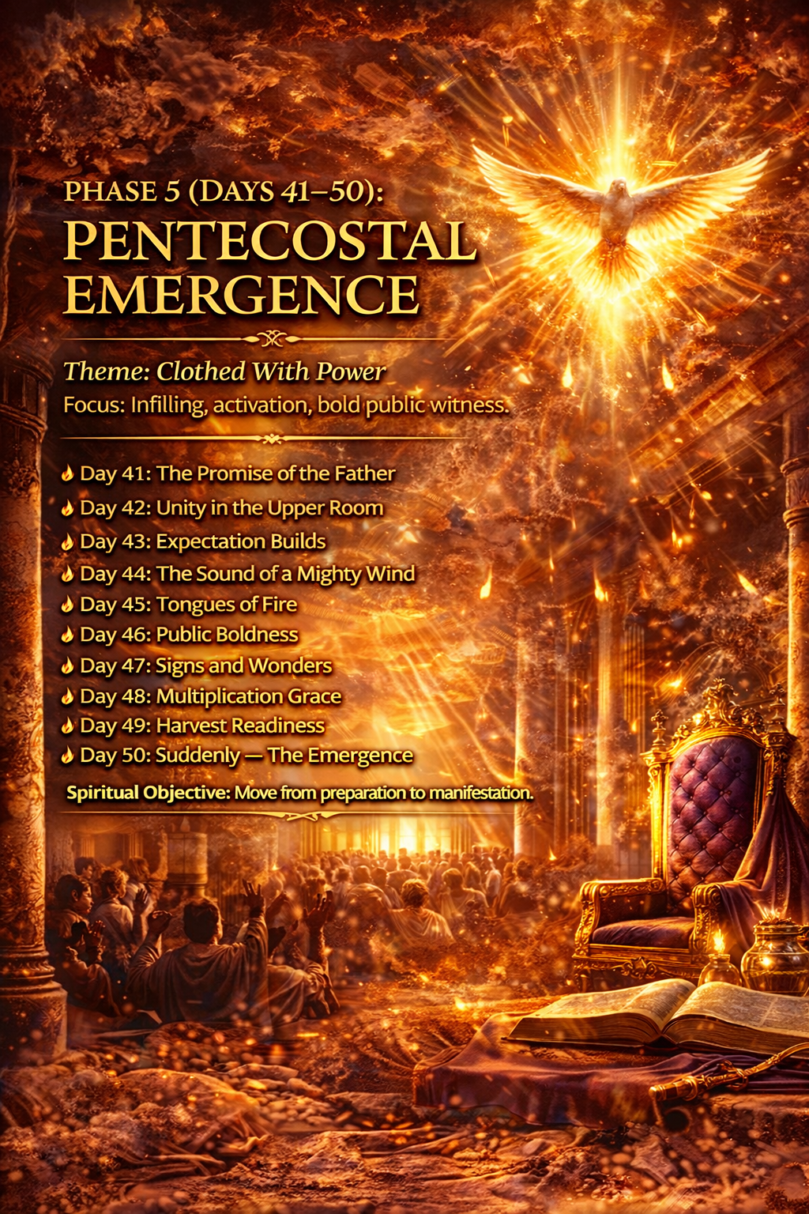

Phase 5 — Pentecostal Emergence

Days 41–50: Clothed With Power
Focus: Empowerment of the Holy Spirit and public manifestation of Kingdom life.
Objective: Move from preparation to Spirit-empowered living.

Day 41 — The Promise of the Father

Theme Scripture
Acts 1:4–5
"Wait for the Promise of the Father… you shall be baptized with the Holy Spirit."

Reflection
Before His ascension, Jesus instructed the disciples to wait for what He called “the Promise of the Father.” Though they had already witnessed the resurrection and received their commission, Jesus knew they would need divine empowerment to fulfill their mission.
This promise was not new. Throughout the Old Testament, God spoke of a day when His Spirit would be poured out upon His people. Joel prophesied, “I will pour out My Spirit on all flesh” (Joel 2:28). The coming of the Holy Spirit would empower ordinary people to participate in God’s extraordinary purposes.
Waiting for the promise required faith. The disciples did not know exactly how or when the Spirit would come, but they trusted the words of Jesus. Their waiting was not passive—it was filled with prayer, unity, and expectation.
Believers today live with the same promise. The Holy Spirit empowers, guides, and strengthens those who follow Christ. As Jesus promised, “You shall receive power when the Holy Spirit has come upon you” (Acts 1:8).

Declaration
I declare that the promise of the Holy Spirit is active in my life. God’s Spirit strengthens my faith, guides my steps, and empowers me to fulfill His purpose.

Prayer
Father, thank You for the gift of the Holy Spirit. Help me live with expectation and openness to Your presence. Fill my life with Your power so that I may walk faithfully in the mission You have given me.

Daily Direction
• Reflect on Acts 1:4–8.
• Pray for deeper awareness of the Holy Spirit’s presence.
• Ask God to prepare your heart for spiritual empowerment.
• Walk today with expectation of God’s work.

Day 42 — Unity Before the Outpouring

Theme Scripture
Acts 1:14
"These all continued with one accord in prayer and supplication."

Reflection
Before the Holy Spirit was poured out on the Day of Pentecost, the disciples were united in heart and purpose. Scripture emphasizes that they were in “one accord,” meaning they shared the same focus, expectation, and devotion. This unity was not accidental; it was cultivated through prayer, humility, and shared commitment to the mission Jesus had given them.
Unity has always been a condition that invites the movement of God. Psalm 133 declares, “Behold, how good and how pleasant it is for brethren to dwell together in unity… for there the Lord commanded the blessing.” When believers pursue harmony and mutual love, they create an environment where God’s presence can move freely.
Jesus Himself prayed for this unity among His followers. In His prayer recorded in John 17, He asked the Father that His disciples would be one, just as He and the Father are one (John 17:21). This unity would demonstrate the reality of God’s love to the world.
Unity requires humility, forgiveness, and shared devotion to God’s purpose. When believers set aside pride and pursue reconciliation, they strengthen the community of faith and prepare the way for spiritual renewal.

Declaration
I declare that my heart is committed to unity with the people of God. I choose humility, love, and forgiveness so that the Spirit of God may move freely among us. As we pursue unity, the blessing and presence of God increase in our lives and communities.

Prayer
Father, align my heart with Your desire for unity among Your people. Remove pride, division, and misunderstanding from my relationships. Help me pursue peace and reconciliation so that Your Spirit may move powerfully in my life and community.

Daily Direction
• Reflect on Psalm 133 and its message about unity.
• Seek reconciliation if there is unresolved conflict.
• Pray with another believer today.
• Ask God to strengthen unity in your church or community.

Day 43 — Expectation in the Waiting

Theme Scripture
Isaiah 40:31
"But those who wait on the Lord shall renew their strength."

Reflection
The disciples waited in the Upper Room with expectation. They did not know the exact moment when the promise of the Holy Spirit would arrive, but they trusted the words of Jesus. Their waiting was filled with prayer, worship, and anticipation.
Waiting seasons often test our faith. When answers seem delayed, it can be tempting to become discouraged or distracted. Yet Scripture teaches that waiting on God is a process through which strength is renewed and faith is deepened.
God frequently works during seasons of waiting. Joseph waited through years of preparation before stepping into leadership (Genesis 41:41). David waited for God’s timing before becoming king (2 Samuel 5:4). Even Jesus waited thirty years before beginning His public ministry (Luke 3:23).
When believers wait with expectation rather than frustration, they begin to see waiting as preparation rather than delay. God uses these moments to refine character, deepen trust, and prepare hearts for the next movement of His Spirit.

Declaration
I declare that my waiting is not wasted. As I trust God’s timing, He renews my strength and prepares me for the next season of purpose.

Prayer
Lord, help me trust Your timing and remain faithful while I wait. Renew my strength and deepen my faith so that I may receive everything You have prepared for me.

Daily Direction
• Reflect on Isaiah 40:31.
• Write down areas where you are waiting on God.
• Pray for patience and renewed faith.
• Thank God for the preparation happening in your life.

Day 44 — The Sound of Heaven

Theme Scripture
Acts 2:2
"And suddenly there came a sound from heaven as of a rushing mighty wind, and it filled the whole house where they were sitting."

Reflection
The arrival of the Holy Spirit at Pentecost was announced by a sound from heaven like a rushing mighty wind. This sound was not merely symbolic; it represented divine movement breaking into human history. Heaven was responding to the prayers, expectation, and obedience of those gathered in the Upper Room.
Wind throughout Scripture represents the movement of the Spirit of God. In Genesis, the Spirit hovered over the waters at creation (Genesis 1:2). Jesus described the Spirit’s activity as wind that moves freely and cannot be controlled or contained (John 3:8). At Pentecost, this same Spirit entered the lives of believers with power and purpose.
The sound from heaven reminds us that God often moves in ways that awaken attention and shift spiritual atmospheres. When the Spirit moves, hearts are stirred, faith is renewed, and spiritual awakening begins. The disciples experienced a moment where heaven’s activity became undeniable.
Today, believers continue to experience the movement of God’s Spirit. Though the circumstances may differ, the principle remains the same: when people seek God with sincerity and expectation, He responds with His presence and power.

Declaration
I declare that the Spirit of God is moving in my life and awakening my faith. The sound of heaven reminds me that God is active, present, and working in ways greater than I can imagine.

Prayer
Father, awaken my heart to the movement of Your Spirit. Let the sound of heaven stir my faith and renew my expectation. Fill my life with Your presence and guide me to walk in alignment with Your purposes.

Daily Direction
• Read Acts 2:1–4 and reflect on the arrival of the Holy Spirit.
• Spend time worshiping God and acknowledging His presence.
• Pray for spiritual sensitivity to the Spirit’s guidance.
• Expect God to move in ways beyond your understanding.

Day 45 — The Fire of God

Theme Scripture
Acts 2:3
"Then there appeared to them divided tongues, as of fire, and one sat upon each of them."

Reflection
Fire has always represented the presence and holiness of God throughout Scripture. When Moses encountered God in the wilderness, the Lord appeared in a burning bush that was not consumed (Exodus 3:2). On Mount Sinai, God descended in fire as He revealed His covenant with Israel (Exodus 19:18). Fire symbolizes both purification and empowerment.
At Pentecost, tongues of fire appeared above each believer. This moment signified that God’s presence was no longer confined to a temple or sacred place. Instead, the Spirit now rested upon individuals, transforming them into living vessels of God’s presence.
The fire of God purifies the heart and ignites passion for His purposes. John the Baptist prophesied that Jesus would baptize believers with the Holy Spirit and fire (Matthew 3:11). This fire removes spiritual complacency and replaces it with zeal for God’s Kingdom.
When believers encounter the fire of God, their priorities change. Fear gives way to courage, indifference gives way to devotion, and hesitation gives way to bold obedience.

Declaration
I declare that the fire of God purifies my heart and ignites my passion for His purpose. My life burns with devotion to Christ and commitment to His Kingdom.

Prayer
Lord, ignite my heart with the fire of Your Spirit. Purify my motives, strengthen my faith, and fill me with passion for Your presence and purpose.

Daily Direction
• Reflect on Matthew 3:11 and the promise of spiritual fire.
• Ask God to renew your passion for Him.
• Worship God with gratitude for His presence.
• Invite the Holy Spirit to purify and strengthen your heart.

Day 46 — Filled With the Spirit

Theme Scripture
Acts 2:4
"And they were all filled with the Holy Spirit."

Reflection
The filling of the Holy Spirit transformed the disciples from fearful followers into courageous witnesses. Before Pentecost, many of them struggled with uncertainty and fear. After being filled with the Spirit, they proclaimed the message of Christ with boldness and conviction.
The Holy Spirit empowers believers for both personal transformation and public witness. Jesus promised that the Spirit would guide believers into truth and remind them of His teachings (John 14:26). The Spirit also provides wisdom, courage, and spiritual gifts for service.
Paul later encouraged believers to continually seek the filling of the Spirit (Ephesians 5:18). This filling is not a one-time event but an ongoing relationship with the Spirit’s presence and guidance.
When believers live under the influence of the Holy Spirit, their lives reflect the fruit of the Spirit—love, joy, peace, patience, kindness, goodness, faithfulness, gentleness, and self-control (Galatians 5:22–23).

Declaration
I declare that the Holy Spirit fills my life with wisdom, courage, and power. His presence transforms my heart and equips me to live faithfully for God’s Kingdom.

Prayer
Father, fill me anew with Your Holy Spirit. Guide my thoughts, strengthen my faith, and empower me to live boldly for Your purposes.

Daily Direction
• Reflect on Galatians 5:22–23.
• Ask the Holy Spirit to guide your decisions today.
• Pray for wisdom and courage.
• Walk consciously in the presence of God.

Day 47 — Boldness to Witness

Theme Scripture
Acts 4:31
"They were all filled with the Holy Spirit, and they spoke the word of God with boldness."

Reflection
After Pentecost, the disciples no longer hid in fear. Instead, they proclaimed the message of Christ openly and courageously. The Holy Spirit transformed their hearts and gave them the confidence to speak truth regardless of opposition.
Boldness does not mean arrogance or harshness; it reflects confidence rooted in God’s presence. When believers understand the message of the gospel and the authority of Christ, they are compelled to share it with others.
Jesus called His followers to be witnesses in the world (Acts 1:8). This witness is expressed not only through words but also through actions that reflect God’s love and truth.
When believers depend on the Holy Spirit, they discover that courage replaces fear and clarity replaces hesitation.

Declaration
I declare that the Holy Spirit gives me boldness to live and speak the truth of Christ. My life reflects His love, and my words carry the hope of the gospel.

Prayer
Lord, give me courage to represent You faithfully. Fill me with the boldness that comes from Your Spirit so that I may speak truth with wisdom and love.

Daily Direction
• Pray for courage to share your faith.
• Encourage someone spiritually today.
• Reflect on Acts 1:8.
• Ask the Holy Spirit to guide your conversations.

Day 48 — The Power of Signs and Wonders

Theme Scripture
Acts 5:12
"And through the hands of the apostles many signs and wonders were done among the people."

Reflection
The early church experienced extraordinary demonstrations of God’s power. Miracles, healings, and signs confirmed the message of the gospel and revealed the authority of Christ.
These miracles were not intended to glorify individuals but to point people toward God. When the lame man was healed in Acts 3, Peter made it clear that the miracle occurred through the power of Jesus Christ.
Signs and wonders remind believers that God is still active in the world. Though miracles may appear in different ways today, God continues to transform lives, heal hearts, and guide His people.
The power of God is not limited to dramatic events. Every life changed by grace is evidence of His work.

Declaration
I declare that God’s power is active in my life and in the world around me. His Spirit works through His people to reveal His love and truth.

Prayer
Father, let my life reflect Your power and grace. Use me as an instrument of encouragement, healing, and truth in the lives of others.

Daily Direction
• Reflect on Acts 3:1–10.
• Pray for those who need healing or encouragement.
• Serve someone in need today.
• Trust God’s power at work through His people.

Day 49 — The Harvest

Theme Scripture
Acts 2:41
"Then those who gladly received his word were baptized; and that day about three thousand souls were added to them."

Reflection
Pentecost did not end with the filling of the Spirit—it resulted in a harvest of lives transformed by the message of Christ. Peter’s sermon led thousands of people to respond in faith, demonstrating the impact of Spirit-empowered witness.
Jesus often spoke about the spiritual harvest waiting in the world. He told His disciples, “The harvest truly is plentiful, but the laborers are few” (Matthew 9:37). The mission of the church is to participate in this harvest by sharing the message of hope and salvation.
Every believer plays a role in God’s redemptive work. Some plant seeds of faith, others water those seeds, and God brings the increase (1 Corinthians 3:6–7).
When believers live faithfully and share the message of Christ, they become part of God’s plan to reach the world with His love.

Declaration
I declare that I am a participant in God’s harvest. Through my words, actions, and prayers, God uses my life to influence others for His Kingdom.

Prayer
Lord, open my eyes to the opportunities around me. Help me recognize those who are searching for hope and guide me to share Your love with wisdom and compassion.

Daily Direction
• Pray for someone who needs spiritual encouragement.
• Reflect on Matthew 9:37–38.
• Look for opportunities to show kindness and compassion.
• Trust God to use your life to influence others.

Day 50 — Suddenly

Theme Scripture
Acts 2:2
"And suddenly there came a sound from heaven."

Reflection
God often moves suddenly after seasons of preparation. The disciples spent days praying, waiting, and trusting God’s promise before the Holy Spirit was poured out at Pentecost. Their faithfulness prepared them for a moment that would change history.
Suddenlies are rarely accidental. They often follow seasons of obedience, perseverance, and spiritual preparation. Throughout Scripture we see this pattern: Joseph’s promotion came suddenly after years of testing (Genesis 41:41), and David’s rise to kingship followed years of preparation (2 Samuel 5:4).
Pentecost reminds believers that God is always working behind the scenes, preparing moments of transformation that may arrive unexpectedly. What begins in quiet prayer can lead to powerful impact.
The same God who moved suddenly in the Upper Room continues to move today. When believers remain faithful and expectant, they position themselves to experience the surprising and powerful movement of God.

Declaration
I declare that I am ready for the suddenly of God. Every season of preparation has positioned me for greater purpose, and I trust His power to move in my life at the right moment.

Prayer
Father, thank You for every lesson and transformation during this journey. Prepare my heart for the moments You have ordained. Let my life reflect the power of Your Spirit and the purpose of Your Kingdom.

Daily Direction
• Reflect on the entire 50-day journey.
• Thank God for the transformation you have experienced.
• Commit to continuing a life of prayer and devotion.
• Step forward with faith, expecting God to move.

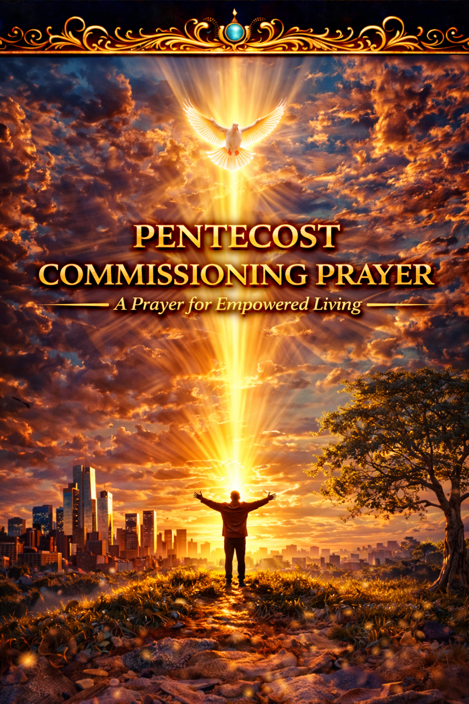

Pentecost Commissioning Prayer

A Prayer for Empowered Living
Heavenly Father,
Today I stand at the conclusion of this sacred journey of consecration, reflection, and spiritual awakening. Over these fifty days You have drawn my heart closer to You. You have refined my character, renewed my mind, strengthened my faith, and reminded me of my identity in Christ.
Just as the disciples waited in the Upper Room with expectation, I have waited in Your presence. And just as You filled them with the power of the Holy Spirit on the Day of Pentecost, I ask that You fill my life anew with Your Spirit.
Lord, clothe me with power from on high.
Let Your Spirit guide my thoughts, strengthen my faith, and empower my words. Remove every fear that attempts to silence my witness and replace it with courage rooted in Your presence.
Your Word declares that we will receive power when the Holy Spirit comes upon us (Acts 1:8). Today I receive that promise by faith.
Fill me with wisdom to discern Your voice.
Fill me with compassion to serve others.
Fill me with boldness to proclaim Your truth.
Fill me with endurance to remain faithful in every season.
Father, let my life become a vessel through which Your love, grace, and truth flow into the world. May the fire of Your Spirit burn within me, purifying my heart and igniting my passion for Your Kingdom.
Send me as Your ambassador.
Where there is darkness, let me bring light.
Where there is discouragement, let me bring hope.
Where there is confusion, let me bring truth.
Where there is brokenness, let me bring compassion.
I surrender my gifts, my time, my voice, and my influence to You. Use my life for Your glory and for the advancement of Your Kingdom.
From this day forward, I commit to living a Spirit-filled life—walking in faith, pursuing holiness, loving others deeply, and representing Christ faithfully.
In the name of Jesus Christ,
and through the power of the Holy Spirit,
Amen.



Living the Emerged Life

Life After the 50 Days
Completing this consecration journey is not the end of the process—it is the beginning of a new season.
The fifty days between resurrection and Pentecost marked a time of preparation for the early believers. They moved from confusion to clarity, from fear to boldness, and from waiting to empowered action. Pentecost did not conclude their story; it launched their mission.
In the same way, this journey has been a season of preparation for you.
During these days you have reflected on the power of the resurrection, rediscovered your identity in Christ, and allowed God to refine your heart through consecration. You have explored spiritual authority and opened your life to the empowering presence of the Holy Spirit.
Now the invitation is to live what has been revealed.
The emerged life is a life that remains anchored in the practices that sustained this journey. It is a life that continues seeking God daily through prayer, Scripture, and worship. It is a life that reflects humility, compassion, and faith in every interaction.
Living the emerged life also means embracing the mission of Christ. Jesus told His followers that they would be His witnesses in the world (Acts 1:8). This calling belongs not only to pastors or leaders but to every believer.
Your influence matters.
Your words, actions, and character can reveal the love of God to those around you. The same Spirit who empowered the early church continues to empower believers today.
The emerged life is marked by several ongoing commitments:
Remain rooted in God’s Word. Scripture provides wisdom, guidance, and spiritual nourishment. As you meditate on God’s Word, your faith will continue to grow and your understanding of His purposes will deepen.
Cultivate a life of prayer. Prayer keeps the heart aligned with God’s will. Through prayer you remain connected to the source of strength, wisdom, and peace.
Walk in obedience. Spiritual growth is sustained through faithful obedience to God’s guidance. Each step of obedience strengthens your relationship with Him and expands your influence.
Serve others with love and humility. The Kingdom of God advances when believers reflect Christ’s compassion and generosity in their communities.
The journey of emergence continues every day as you follow Christ. The same Spirit who moved in the Upper Room is still at work in the world today. And now, empowered by His presence and guided by His truth, you are invited to walk forward in faith—living as one who has emerged into the life God prepared for you.
The journey continues.

